# Mastering SQL Server Profiler

# Introduction

I have been a SQL Server DBA for about 14 years, and I regard Profiler as one of the most useful of SQL Server’s “built-in” tools. Profiler records data about various SQL Server events. This data is stored in a trace file and allows you to view the communications send form a client to SQL Server, in addition to giving you and insight into its internal workings. This information can be used to troubleshoot a wide range of SQL Server issues, such as poorly-performing queries, locking and blocking, excessive table/index scanning, and a lot more.

For such a potentially powerful tool, Profiler is surprisingly underused. This must be due, at least in part, to the fact that it is occasionally a frustrating too. The use interface is poor, it lacks many important features, it is poorly document and, unless you have a lot of experience as a DBA, it is often hard to analyze the data you capture. As such, many DBAs tent to ignore it and this is distressing, because Profiler has so much potential to make a DBA’s life more productive.

This is why I wrote this book, *Mastering SQL Server Profile*r. My goal was to make it easier for you to learn how to use Profile, analyze the data it provides, and no take full advantage of this potential for troubleshooting SQL Server problems.

## WHICH VERSION OF SQL SERVER PROFILER IS COVERED IN THIS BOOK?

Most DBAs are still SQL Server 2005, so all the examples in this book are based on SQL Server 2005 Profiler. However, the differences between SQL Server 2005 and SQL Server 2008 are minimal. While you may notice some minor cosmetic changes between the two editions, and discover that SQL Server 2008 includes a few new events, every example in this book will working with SQL Server 2008 and everything you learn here is applicable to both SQL Server 2005 and SQL Server 2008.

In fact, most of what is covered in this book also applies to SQL Server 2000, although you will want to use the SQL Server 2005 Profiler tool to access your SQL Server 2000 instances.

## HOW TO BOOK IS STRUCTURED

If you are new to Profiler, you will want to start with the first three chapters, which provide the basic foundation you need to begin using Profiler. If you’re already familiar with the basics of capturing traces with Profiler, then you can head straight to Chapter 4 and onwards. These chapters are self-contained and can be read in any order that you wish.

### CHAPTER 1: GETTING STARTED WITH PROFILER

If you are new to Profiler, this is where you will want to start. This chapter covers all the basics you need to get you started using Profiler, such as:

* Understanding how Profiler works
* An introduction to Profiler terminology, such as events, data columns, filters and traces
* Learning the basics of how to create, control, and save a Profiler trace

### CHAPTER 2: WORKING WITH TRACES AND TEMPLATES

This chapter delves deeper into the world of traces. It covers topics such as:

* How to build custom traces from scratch
* How to Save Profiler traces to a SQL Server Table
* How to trace Analysis Services activity
* How to create and modify reusable profiler trace templates

### CHAPTER 3: PROFILER GUI TIPS AND TRICKS

At this point, you should have a good understanding of what Profiler can do and how it works. This chapter covers several Profiler tips will make you more productive, such as:

* Tips on Selecting Profiler Events and Data Columns
* Tips on Using Column Filters
* Tips on Organizing Columns for Grouping and Analysis
* How the “Server processes trace data” Option Affects Traces
* How to Set Global Trace Options
* How to Schedule a Trace’s Stop Time
* How to use the Auto Scroll Window
* How to Search for Data Inside a Trace File
* How to Set and Use Bookmarks

### CHAPTER 4: HOW TO IDENTIFY SLOW RUNNING QUERIES

Now that you have mastered Profiler basics, you get the opportunity to start making practical use of Profiler. As DBAs, one of the problems we face on an almost daily basis is slow-running queries. These are the kind of queries that keep us up late at night, running our sleep and turning us into zombies. This chapter show you how to:

* Create a Profiler trace to capture all the information you need to identify and analyze slow running queries.
* Analyze the poorly-performing queries identified by Profiler.

### CHAPTER 5: HOW TO IDENTIFY AND TROUBLESHOOT SQL SERVER PROBLEMS

This chapter shows how to create and analyze Profiler traces that will help you uncover a multitude of different problems (possibly problems that you didn’t even know you had!). In this chapter, you will learn:

* How to Identify Deadlocks
* How to Identify Blocking Issues
* How to Identify Excessive Auto Stats Activity
* How to Identify Excessive Statement Compilations
* How to Identify Excessive Database File Growth/Shrinkage
* How to Identify Excessive Table/Index Scans
* How to Identify Memory Problems

### CHAPTER 6: USING PROFILTER TO AUDIT DATABASE ACTIVITY

Many DBAs are tasked with auditing the activity within their databases. Although Profile is not the ideal tool for auditing, it can still get the job done. This chapter covers:

* The pros and cons of using Profiler for auditing
* Available Audit events
* How to conduct an Audit Trace

### CHAPTER 7: USING PROFILTER WITH THE DATABASE ENGINE TUNING ADVISOR

In combination, Profiler and the Database Engine Turning Advisor can make it much easier for DBAs to identify indexing issues in your databases. In this chapter, you learn:

* About the features and benefits of using the DTA
* How to create a trace for use by the DTA
* How to run a trace for use by the DTA
* How to Perform a Missing Index Analysis Using the DTA

### CHAPTER 8: CORRELATING PROFILER WITH PERFORMANCE MONITOR

Data captured in Performance Monitor and Profiler can be combined and displayed within the Profiler GUI, making it possible to identify correlations between Transact-SQL execution and resource usage. In this chapter, you learn:

* How to collect Profiler data for correlation analysis
* How to collect Performance Monitor data for correlation analysis
* How to correlate SQL Server 2005 Profiler data with Performance Monitor data
* How to analyze correlated data

### CHAPTER 9: HOW TO CAPTURE PROFILER TRACES PROGRAMMATICALLY

While most DBAs create and collect traces using the Profiler GUI, there certain advantages to using T-SQL scripts and system stored procedure. In this chapter, you will learn:

* The pros and cons of capturing traces programmatically
* How to use T-SQL and system stored procedures to capture traces
* How to use the Profiler GUI to create T-SQL trace scripts
* How to use a trace function to perform SELECT queries directly against a physical trace file

### CHAPTER 10: PROFILER BEST PRACTICES

There are many different ways to use Profiler to capture trace data. This chapter summarizes some of my thoughts on the most efficient ways to:

* Create Traces
* Run Traces
* Analyze Traces
* Use Performance Monitor with Profiler
* Use Database Engine Tuning Advisor with Profiler

### CHAPTER 11: PROFILER EVENT AND DATA COLUMNS EXPLAINED

We saved the longest chapter for last. It provides a reference source for each of the 21 Profiler event categories that Profiler has to offer, and to offer an explanation of how they can be used to troubleshoot many different SQL Server problems. It includes a description of those events in each category that will be of the most interest to the DBA with a digest of the most important data columns.

### HAVE FUN, AND LET THE PROFILER ADVENTURE BEGIN

Now that you know where you are going, jump in with both feet and begin your journey towards mastering Profiler. Learning is always a great adventure, and I hope you enjoy reading this book as much as I did researching and writing it. If you have any questions or feedback, please send them to [brad.mcgehee@red-gate.com](mailto:brad.mcgehee@red-gate.com).

# Chapter 1 GETTING STARTED WITH PROFILER

SQL Server 2005 Profiler is a powerful tool that allows you to capture and analyze events, such as the execution of a stored procedure, occurring within SQL Server. This information can be used to identify and troubleshoot many SQL Server-related problems.

Everybody has no start somewhere and, if you are new to Profiler, this is where you want to begin. In this chapter, we’ll cover the basics of how Profiler works, its core terminology, and how to create and save basic Profiler traces.

If you have used Profiler a lot in the past, you may want to skip right to the later, more advanced chapters in the book where we start to put Profiler into action, analyze slow performing queries, troubleshooting bottleneck, auditing database activity and so on.

After reading this chapter, you will know why Profiler is such an essential tool in the DBA’s armory, and will:

* Understand how Profiler works
* Be familiar with core Profiler terminology, such as events, data columns, filters and traces
* Understand the permissions required to use Profiler and how to start up Profiler
* Be able to create and control basic Profiler traces and then save a completed trace to a file.

## WHY MASTERING PROFILER CAN HELP MAKE YOU AN EXCEPTIONAL DBA

One of the things that separate mediocre DBAs from exceptional ones is that exceptional DBAs know how to take full advantage of the tools available to them. By mastering Profiler, the exceptional DBA can track down and fix SQL Server performance and other problems quickly and efficiently, and even spot potential problems before they cause real difficulties. In this section, we take a look at the many different ways we can use Profiler to help us out in our job.

While the following lists are not totally comprehensive, they do describe the majority of the ways profiler can be used to help us out as DBAs or developers.

### How PROFILER CAN HELP DBAs

* Monitor the activity of the:
  + SQL Server Database Engine
  + Analysis Services
  + Integration Services
* Monitor and identify performance-related problems with front-end application, queries, T-SQL, transactions, and much more
* Perform query analysis of execution plans
* Monitor and identify SQL Server errors and warnings
* Capture and replay traces of activity to replicate problems
* Audit user activity
* Analyze trace results by grouping or aggregating them
* Create your own custom traces, and save then, for use whenever you wish
* Correlate Profile trace events with System Monitor performance counters to identify what event(s) are hogging server resources
* Capture data for analysis in the Database Engine Tuning Wizard
* Save trace results to a file, a database table, or to XML for later analysis
* Trace Profiler events programmatically, instead of using only the Profile GUI

### How PROFILER CAN HELP DEVELOPERS

* View how SQL Server works when interacting with a client
* Debug T-SQL code and stored procedures
* Perform stress testing
* Perform quality assurance testing

As discussed in the book’s introduction, the focus of this book is on DBAs, not developers. Because of this, we will be focusing on the type of features described above that are targeted more toward DBAs.

## THE INNER WORKINGS OF PROFILER

What may be a surprise to many DBAs and developers is that SQL Server Profiler is only a GUI designed to work with another feature of SQL Server called **SQL Trace**. It is SQL Trace that is actually doing most of the work when it comes to capturing SQL Server events and storing then for later use. SQL Trace is a feature of SQL Server than can be accessed indirectly with the Profile GUI, system stored procedures, or programmatically using Server Management Objects (SMO).

In essence, SQL Trace is a very simple tool. Its job is just to capture SQL Server-related communication between a client and SQL Server. It acts similarly to specialized network sniffer that captures traffic on the network related to SQL Server and allows you to see exactly which events are being sent from the client to SQL Server.

Unlike a network sniffer, which allows you to see every byte traversing the network, SQL Trace only captures and processes SQL Server –specific events. Here’s how it works.

|  |
| --- |
|  |
| Figure 1-1: The flow of Profiler data from SQL Server events to final output |

First, a SQL Server-related event is created between a client or SQL Server process and SQL Server Events include many different types of activities and will be described in more detail later. As these events are occurring in SQL Server, it is SQL Trace’s job to capture specific SQL Server events that are of interest and to filter out those of no interest.

Once the events are captured, they are queued up in memory. At this point, they can be sent directly to a database table, to a physical file, or to and SMO-based application.

|  |
| --- |
| **Note**  Server Management Objects (SMO) is an object model that can be used to directly access SQL Server, including SQL Trace. In fact, the SQL Server Profiler GUI is actually a SMO-based application that interacts with SQL Trace. |

In addition to SQL Server Profiler, SQL Server includes many system-stored procedures that use the SMO object model to interact with SQL Trace. We will discuss these system-stored procedures later on. Developers can also directly access SQL Trace using SMO objects, although this topic is not discussed in this book.

In effect, this mean that SQL Trace is a black box that we can’t directly access. All we can do is to interact with it indirectly with various tools. In our case, these tools will be Profiler and system-stored procedures.

## PROFILER TERMINOLOGY

At school, I hated learning new terminology. Unfortunately, there is some basic Profiler terminology that we need to thoroughly understand before we can processed any further. We will introduce four key terms now and expound on them later when appropriate.

These terms are:

* Events
* Data columns
* Filters
* Trace

### EVNETS

I have already used this term several times, without properly explaining what on event is. Essentially, it is the occurrence of some defined action inside SQL Server. The execution of a stored procedure is one example of an event. SQL Server Profiler allows you to capture over 170 different SQL Server-related events. An **Event Category** is a group of related events. For example, the Stored Procedure event category groups together all events relating to the execution of a stored procedure. This event category will include events that, for example, allow you to capture information about when a procedure started executing, completed executing, and so on. The term Event Class refers to an event, and all of the **data columns** associated with in.

### DATA COLUMNS

Every event that can be captured includes a group of related data that describes that event and is stored in what are called data column. Think of an event as a row in a database and data columns as the column in a worksheet. Different events are associated with different data columns, and not every data columns is available for every event, as you can see in Figure 1-2.

|  |
| --- |
|  |
| Figure 1-2: The left column above shows some of available events for the Event Class called Stored Procedures. The columns to the right are the data columns that include the data captured for each event. |

Examples of the data columns for a stored procedure event include EventClass, TextData, AppliationName, Reads, Writes, and Duration. Profiler offers 64 different event columns, although no event uses all of the available data columns. This data is very useful to the DBA or developer when analyzing specific events.

### FILTERS

Many times you will want to capture information about a certain event, but only when it occurs under specific circumstances, rather than every single time the event occurs. For example, maybe you only want to capture events from a selected user, a specific application, or for a given database. Filters allow you to tell Profiler not to collect the events (rows) that you don’t want to save or view.

|  |
| --- |
|  |
| Figure 1-3: The above is an example of how you create a filter with Profiler. In the above example, we are filtering out all events that are not generated by the database with a DatabaseID of 5. |

### TRACES

A trace includes the events and data columns you collect and is usually stored in a physical file for later examination. A trace file can be saved in many ways.

It can be:

* Stored in memory of Profiler
* Exported to a proprietary Profiler file format
* Exported to a database table
* Exported to an XML file

In essence, your goal is to use Profiler to capture and save trace files for analysis.

|  |
| --- |
|  |
| Figure 1-4: This is a small example of an actual trace displayed in Profiler. It shows events as rows and data columns as columns. |

## GETTING STARTED WITH PROFILER

Now that we have covered the basics, we’re going to start using the tool. You will get the most out of this book if you read it sitting in front of your computer, having access to a test or production SQL Server 2005 instance, Management Studio, and SQL Server Profiler. While you may be wary of working on a production instance, you need not be. Most of what we will do with Profiler will have minimal performance impact and can’t hurt your production instance. There are a couple of exceptions to this, and I will clearly point them out at the appropriate time.

While a test server is perfectly adequate, the advantage of using a production instance is that you will be able to capture real and interesting events. If you only have access to a test SQL Server instance, you will want to write a script to simulate some database activity, so you can better follow the examples in this book. The following script, for example, does nothing special, except put a small load on your server so that you are able to capture some Profiler Events. As an alternative, there are serveral SQL Server stress tools on the market (Google “SQL Server stress test”) that you may want to download and try. Most of these have free trial periods that will be more than adequate for simulating a SQL Server load for Profiler to trace while you are following the examples in this book.

|  |
| --- |
| USE [AdventureWorks]  EXECUTE dbo.uspGetEmployeeManagers 1  GO |

### PERMISSIONS REQUIRED TO USE PROFILER

As you might imagine, you just don’t want just anyone to create, view, or play back a Profiler trace. If that were possible, anyone could see the data moving between client applications and SQL Server.

By default, only as SA, or a member of the SYSADMIN group, can create and run a Profiler trace, or replay an existing trace. In SQL Server 2005, it is now possible for SAs or SYSADMINs to grant Profiler permission to any SQL Server user. This, of course, is potentially dangerous permission to assign, so it must be done with utmost discretion.

To assign SQL Server Login ID permission to use Profiler, an SA or member of the SYSADMINs group must grant the ALTER TRACE permission, like this:

USE master;

GRANT ALTER TRACE TO LoginID;

GO

To remove this permission, use this statement:

USE master;

REVOKE ALTER TRACE FROM LoginID;

GO

### How TO START UP PROFILER

There are a couple of ways you can start up the Profiler GUI. Use whichever option is more convenient for you and appropriate to the operating system you are using. The following example assumes that you are using Vista as your desktop OS to run Profiler.

If you are at the Desktop, go to:

Start 🡪 All Programs 🡪 Microsoft SQL Server 2005 🡪 Performance Tools 🡪 SQL Server Profiler

Or, if you have Management Studio or the Database Engine Tuning Advisor already open, then in each case you can go to:

Tools 🡪 SQL Server Profiler

Or, if you prefer the Command prompt, type in the following and press ENTER:

**profiler90:**

Personally, I think all of the above options are too much work. I prefer to create a Profiler shortcut and add it to my Quick Launch bar.

At this point, you can begin following along with me on your own computer. It is a greate way to speed up your mastery of Profiler.

### GETTING FAMILIAR WITH THE PROFILER GUI

In this section, we take a brief look at the Profiler GUI, so we have a frame of reference for when we drill down into the details of this tool. One Profiler is launched, using any of the techniques described above, you get the less-than-intuitive and informational screen shown in figure 1-5:

Figure 1-5: The Profiler GUI.

I’m betting that Microsoft must have spent over a million dollars just to design this screen, as it is so useful. Or maybe they saved a million dollars. I’m not sure which.

Seriously though, am I the only one who finds this user interface a litter hard to figure out? For example, what’s your first step? Even the icons at the top of the screen confuse me. But again, I have problems reading most street signs, so perhaps I am not a good person to offer an opinion.

To get Profiler up and running, click on the File menu (see Figure 1-6 below). From here, it gets easier, I promise.

Figure 1-6: The File menu is where you begin using Profiler.

We will eventually examine all the options available in this menu, and the rest of the GUI, but for now, selecting “New Trace” is the best way to get started. After selecting “New Trace”, you get a screen similar to the one shown in Figure 1-7:

Figure 1-7: You must always log in to Profiler before you can use it.

As we already discussed, not just anyone can use Profiler to capture SQL Server trace data. So before we can begin using Profiler for any task, we have no log in for SQL Server to verify that we have the proper permissions to use Profiler.

In order to log in, we must tell Profiler what kind of server we want to Profile (Data Engine or Analysis Services), the name of the server we want to access with Profiler, and the kind of authentication we want to use in order to have our credentials verified. This is all straightforward, and is exactly how we log in to Management Studio.

Assuming we have the proper credentials and have selected a running instance of SQL Server, we will see the following screen after clicking on “Connect.”

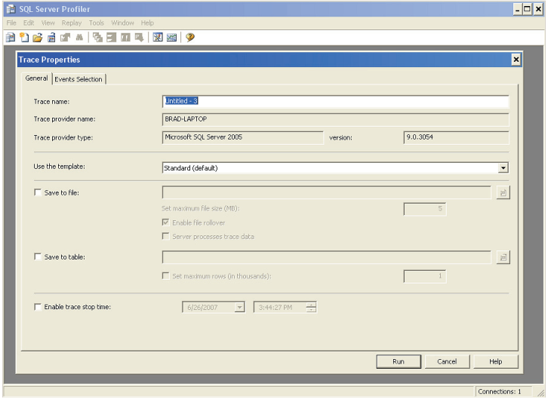

Figure 1-8: The Trace Properties screen is where you start to create a trace.

As you can see, there are lots of options on the first tab of this screen (“General”), and a second tab (“Events Selection”) that we haven’t even looked at yet. To keep things easy, we are going to start out by explaining the top two parts of this screen, then the rest for later sections. No point overwhelming ourselves too soon.

So, let’s first take a closer look at the top portion of the Trace Properties screen, as seen in Figure 1-9:

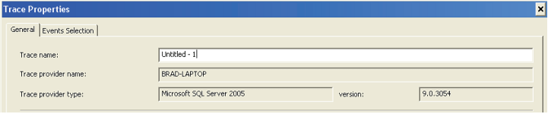

Figure 1-9: You should assign traces a name so you can easily refer to them.

One of the first things you need to do when you create a new Profiler trace is to give it a name. If you don’t, then Profiler will automatically assign an easy-to-remember name (not), such as Untitled-1, for you. Assign a descriptive name that will make it easy for you to remember what this particular trace is for.

Notice that the next three boxes are grayed out. This is great; these are all filled in for you. If you are not in a big hurry, you might want to verify that the information is correct:

* **Trace Provide Name** should be the name of the SQL Server instance you are going to Profile
* **Trace Provider Type** should be the version name of the SQL Server instance Profile you are going to capture.
* **Version** is the numerical version of the SQL Server instance you are profiling

Here’s some “inside into”. SQL Server Profiler can capture Profiler traces of both SQL Server 2000 and 2005. Events and data columns will vary somewhat with each version, but that is to expected as the feature set between product versions is somewhat different.

If any of these is not what you expect, you probably logged in to the wrong instance and need to exit Profiler and start over again.

Now let’s a brief look at the second, “Use the template”, section of this screen, as seen in Figure 1-10:



Figure 1-10: Templates are a powerful feature of Profiler

So what exactly is a template? Remember when we defined events, data columns, filters, and traces earlier? Essentially, a template is predefined trace, which includes predefined events, data columns, and filters. Profiler comes with a variety of templates you can use, or you can create your own. Once you create your own template, you can use it over and over again, saving a lot of time.

We are going to return to the theme of template later chapters, but for now all you need to understand is that in Profiler, the Standard template is the default, which means that the events and data columns that define this template have already been selected and are ready for use. You can see which events are covered by this template by clicking on the “Events Selection” tab, although we will save the details of that to the next chatper.

This means that, without any further work, simple click the “Run” button and you can start collecting trace data, which is exactly what we will do next!

### CAPTURING BASIC TRACES

Finally, we get to do some fun stuff! Up to this point, all we have covered is background information. Now we get to perform our first trace. The goal of this section is to show you how to start, pause, and stop traces, and learn when you should use each option. We will be using the standard (default) predefined trace template, and accept all the Profiler default options.

|  |
| --- |
| **Note**  If you want to follow the examples, but don’t have a production SQL Server to connect to, consider running the T-SQL code provided earlier. You will need to run it in Management Studio each time you want to simulate some SQL Server activity. |

Please note before you start running any trace in Profiler, that the collected events are stored in the RAM of the computer where Profiler is running. So, if you are at the server, valuable RAM is being used by Profiler to store this data. That is why it is a good idea to run Profiler on a computer other than the SQL Server you are monitoring. This way, SQL Server doesn’t have to compete for memory with Profiler. At some point, it is possible for your computer to run out of RAM to hold all the Profiler events. When this happens, your computer begins to use the Operating System swap file for additional memory, greatly slowing down your computer. Later in the book we will talk about how to avoid this problem. For now, just keep your traces short to prevent any unexpected problems.

#### HOW TO START A TRACE

Let’s start at the beginning.

**Step 1**: Start Profiler.

**Step 2**: Select File 🡪 New Trace

**Step 3**: The “Connect to Server” screen appears. Login in to the SQL Server instance you want to profile. This can be any running SQL Server instance.

**Step 4**: You should now be at the “Trace Properties” screen. For now, we are going to leave all the options at their default setting. This is because our goal now is to learn how to start a trace, and nothing more.

**Step 5**: To start your first trace, click on “Run” at the bottom of the screen. Congratulations! You have just learned how to start a Profiler trace. The trace screen now appears (see figure 1-11). As new trace events occur, you will see them appear on the screen. As you can imagine, the events you see in the figure below will be different from the events you will be capturing.

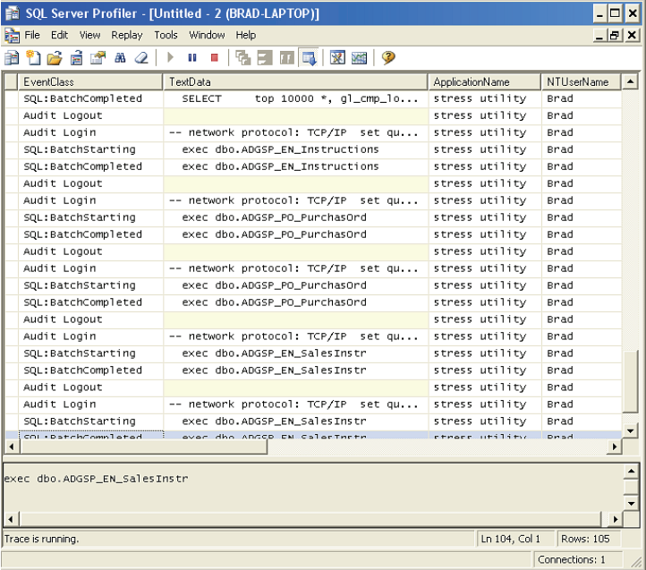

Figure 1-11: A partial screen shot of a running trace.

While we are at this screen, there are a few things you need to learn. First, be aware that each row on the screen is an event that has been captured by Profiler. Second, each column on the screen represents a different data column. Notice again that not all events include all data columns. This trace has many data columns, and they are not all shown on this screen. You can scroll to the right to see them all.

The screen itself is divided into two areas. The top portion of the screen lists the events. The bottom portion of the screen (the gray area) shows you the complete contents of the **TextData** data column. If you can’t see all the TextData in the lower window, you can choose to resize the height of the two windows, or you can scroll either of the two windows up and down to view the TextData.

At the very bottom left of this screen, notice the message “Trace is running” which tells you that the current state of the trace. Other messages that can appear here are “Trace is paused” and “Trace is stopped.”

At the bottom right of the screen, you see several different types of information. First is the Line and Column number of the row that is currently selected by the cursor. In this case, it is Line 104 and Column 1. “Rows” refers to the total number of rows (or events) that have been captured so far. When a trace is running, this number generally increments very quickly.

As you view a live trace, new events are continually added and displayed on the screen. In our example, new events are being added to the bottom of the top window.

#### HOW TO PAUSE A TRACE

Pausing a trace means exactly what is says. When you pause a trace, you are telling Profiler to stop collecting events and wait until you either restart the trace or stop it. When you restart a paused trace, any events that occurred between the time you paused and unpaused is are gone and can’t be recovered. But when you restart (unpause) the trace, Profiler will again begin collecting events, adding them to the screen from the moment you unpaused.

Pausing and unpausing a trace can be handy when you are trying to “capture” an event with the Profiler without collecting more events than you need. Think of pausing as a way as to control when you collect data, and when you don’t, for short Profiler trace captures.

There are two ways to pause Profiler from the GUI. First, you can select the File menu at the top of the screen and select “Pause Trace.” Or, you can click on the “Pause Trace” icon, which looks like this.

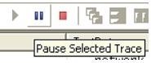

Figure 1-12: You can pause a trace by clicking on the Pause icon.

If you haven’t done so already, give it a try and pause the trace. When the trace is pause, you will see “Trace is paused” at the bottom left of the screen.

To unpause a trace, you can either select the File Menu at the top of the screen and select “Run Trace”, or you can click on the “Start Selected Trace” icon, which looks like this.

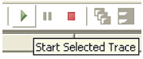

Figure 1-13: You can unpause a trace by clicking on the Start Selected Trace icon.

#### HOW TO STOP A TRACE

When you decide to stop a trace, you are telling Profiler that you are completely done with this trace and do not want to restart it later. If you attempt to start a trace after it has been stopped, it will delete the event data from the old trace from memory and start fresh. So, only stop a trace if you know that you don’t want to restart it again.

There are two ways to stop a Profiler trace from the GUI. First, you can select the File menu at the top of the screen and select “Stop Trace.” Or, you can click on the “Stop Trace” icon, which looks like this:

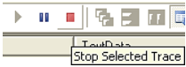

Figure 1-14: You can stop a trace by clicking on the Stop Trace icon.

After stopping a trace, you will see the message “Trace is stopped” at the bottom left of the screen. Once a trace is stopped, you can view it or save it for later viewing. We will learn how to save a trace later in this chapter.

#### HOW TO CLEAR A TRACE

Clearing a trace allows you to remove the current trace results from RAM. If you have saved these results, the saved results aren’t affected by this option; only the RAM is cleared. I rarely need to use this option, as starting a new trace automatically clears the current trace.

There are two ways to clear a Profiler trace using the GUI. First, you can select the Edit menu at the top of the screen and select “Clear Trace Window.” Or, you can click on the “Clear Trace Window” icon, which looks like this:



Figure 1-15: You can clear a trace from memory by clicking on the Clear Trace Window icon.

Once you have cleared a trace, you can start a new trace at any time.

#### HOW TO SAVE A COMPLETED TRACE TO A FILE

In many cases, you will want to save your Profiler traces. You may not have time right away to analyze the trace, you may want more time to analyze the data, you may want to share the data with others, or to archive the trace results so you can compare them to traces taken later. In this section, we take a look at how to save a trace after it has been captured and stored in RAM. In the next chapter, I’ll explain how to save a trace as it is being run.

Traces can be stored in a trace file (.trc format) or directly in a database table. In almost all cases, you will want to store traces in the trace file format, as it is the most efficient way to store them. Should you decided you want to store your traces in a database table, we will show you how to do that in a later chapter.

If you are following on your computer, start the default trace we have already been discussing. Be sure that some trace events have been captured in the trace window.

Now, let’s save the trace to a trace file.

**Step 1**: Stop the trace. While it is not required to stop a trace before you save it, it makes sense that you would only really need to save a trace once it is complete and has been stopped.

**Step 2**: From the main menu, select File 🡪 Save, and you will get a standard Windows save dialog box. You can choose to save trace files anywhere you want. By default, trace files are stored under My Documents. You must give the trace file a name. So choose any folder and filename that works for you, then click “Save,” and the file is saved. If you have accidentally selected a name already used, you will be asked if you want to overwrite the old file.

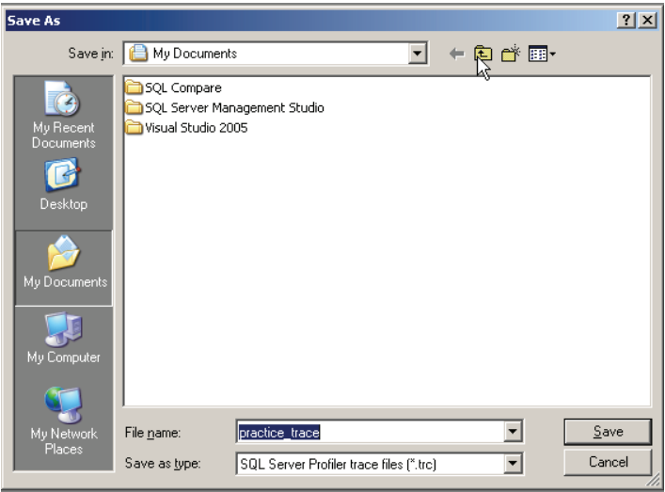

Figure 1-16: Trace files are saved like any other files in Windows.

The trace has now been saved. Notice that the trace is still in RAM. Saving a trace does not affect the trace currently in RAM. At this point, you can choose to clear the trace, start a new trace (which clears the current trace), or exit Profiler, which also clears the trace from RAM.

#### HOW TO LOAD SAVED TRACE

Once you have created and saved a trace, it is very common for a user to want to reload it into the Profiler GUI for additional analysis. For our example, let’s assume that we want to load the trace we just created in the previous section. If you are following on your own computer and have not done so yet, exit Profiler, so we can all start from the beginning.

Follow these steps to load and existing trace file.

**Step 1**: Start Profile.

**Step 2**: Next, select File 🡪 Open 🡪 Trace File, as shown below.

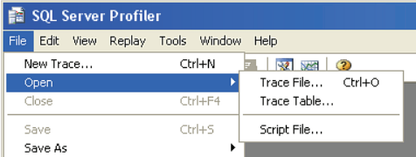

Figure 1-17: How to open an existing trace file.

**Step 3**: A new screen appears.

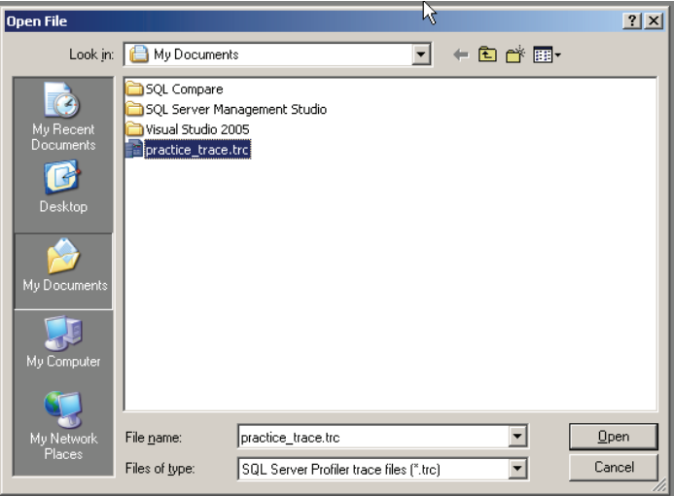

Figure 1-18: select the existing trace you want to open.

Select the trace you want to open and click on the “Open” button, and the trace will appear, just like it did after you did the initial trace capture.

## SUMMARY

Believe it or not, you have just mastered the basics of getting Profiler up and running. Without wishing to scare, though, it has to be said that we have barely scratched the surface of what Profiler is capable of and we have a long way to go. But we have made a good start.

Now, let’s drill down and learn how to master this powerful, though inelegant, tool.

# Chapter 2 WORKING WITH TRACED AND TEMPLATES

As you have probably guessed, there is a lot more to Profiler than using the default template and simply clicking “run.” More usually, you’ll want to create and save your own custom traces, tailed to the specific problem you are trying to solve.

The first goal of this chapter is to introduce you to the fundamentals of creating a new trace using a simple example. This will include selecting events and data columns, applying filters, ordering columns, as well as running the trace and saving it to a file or to a database table. Although this book is focused on profiling database engine events, I’ll also briefly show you how to you can apply the same knowledge of creating traces to profiling Analysis Server events.

We will then return to the topic of templates. Creating your own custom traces is a fundamental skill, but it would be a mistake to dismiss the built-in templates that Profile provides, as they can save you a lot of time and effort.

We’ll examine these built-in template first, then investigate how to modify them to create your own custom templates, finally to build your own template from scratch. We’ll even see how to import and export templates, as Exceptional DBAs often maintain a collection of Profiler Trace templates that they share with co-works and other DBAs.

## UNDERSTANDING THE EVENTS SELECTION OPTIONS

In chapter 1, we spent all of our time on the “General” tab of the Profile GUI, barely glancing at the “Events Selection” tab. Before we start creating custom traces, we need to quickly review this tab. Its name is not very accurate, since not only does it allow you to select events, but also to sort events, select data columns, and to filter events.

If you leave all the default options on the General tab, and switch over to Evens Selection, you’ll see the screen show in Figure 2-1:

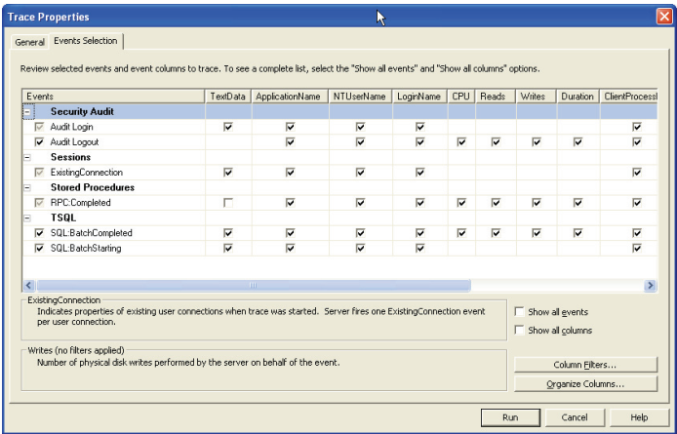

Figure 2-1: The Default Events Selection screen

|  |
| --- |
| **Note**  Figure 2-1 is not quite the “default” Events Selection screen. I’ve expanded the data columns so you can read their names in full. You do this by simply dragging the right edge of the column across, or double-clicking on it. Unfortunately, changes in column width are not saved, so the next time you bring up Trace Properties window, you will have to repeat this step. |

The first column on the screen is “Events”. This is where you select one or more events to be captured in your trace. Here, we can see four event categories (in bold) and six events. All the remaining columns are the available data columns associated with each event. A checked box in a column means that the data column will be captured for that event. The existence of an empty box means that the data column in question is available for the given event, but is currently not set to collect data. For example, in figure 2-1, the **TextData** data column is available for the **RPC:Completed** event, but is not selected. If there is no box, then the data column is not available for that event – for example The **CPU**, **Reads**, **Writes** and **Duration** data columns are not available for the **ExistingConnection** event.

In figure 2-1, Profiler is showing you a default selection of events and database columns: those that comprise the Default template. In fact, this is just a small subset of the events and data column that are available to you. In order to see them all, simply check the “Show all events” and the “Show all columns” check boxes in the lower right portion of the screen:

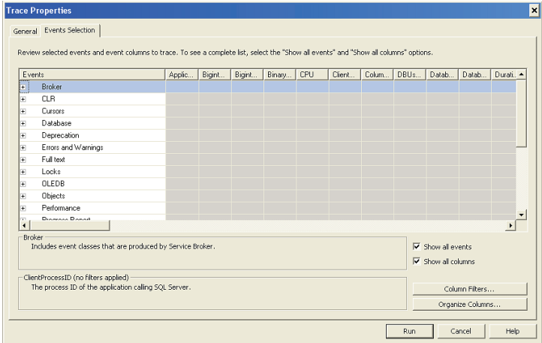

Figure 2-2: The Events Selection screen showing all events.

The screen is now showing you only “event categories,” not specific events. This is why there are no longer any options to select or deselect the data columns. To see specific events, you have to click on the plus sign next to each event category, at which point the check boxes for the data columns will reappear.

Directly below the rows and columns that represent the event and column data to be collected are two Help boxes. In figure 2-3 below, you see that “Broker” event categories is named in the top Help box, and below that is a brief description of the events found in this event category.

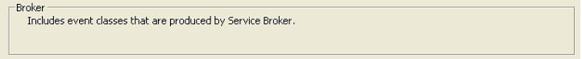

Figure 2-3: This Help box is for events

In figure 2-4 below, the bottom Help box says “ClientProcessID (no filters applied), with a short description below. This Help box describes the data columns the mouse is hovering over. So if you move the mouse to other data columns, you will see different Help information for each different data column. The words “no filters applied” tell you that no filter has been applied to this data column. We will learn more about filters shortly.

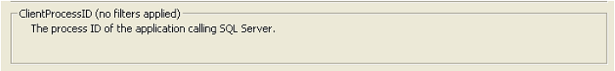

Figure 2-4: this Help box is for data columns.

Now that we understand how the two Help boxes work, let’s take a quick look at the remaining part of the Trace Properties screen, as shown in Figure 2-5 below.

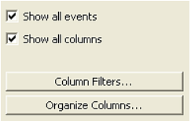

Figure 2-5: This portion of the Trace Properties screen allows you to perform many more tasks than you might imagine.

As we have seen, the top options shown in Figure 2-5 allow you to show, or not show, all the available events and data columns. I leave these options on when I am selecting which events and data columns to collect for a particular trace, so I can see what is available. I am getting old and can’t remember as well as I used to, but once I have selected all the events and data columns I want to trace, I often deselect these two options. When you do this, only the events and data columns you have selected remain, making the screen a bit easier to read.

The “Column Filters...” button allows you to filter out any events (together with their data columns) that you don’t want to capture. The “Organize Columns...” option is used to perform two tasks. First, you can use it to arrange the order of the data columns on the screen when a trace is running. Second, it allows you to group events by a single event type. Both these are large subjects and deserve their own sections; they are discussed later.

Now that you know your way around both tabs, we can move on to see how to create a new trace from scratch. While you don’t have to follow the order I have outlined below, it is a practical approach and you might want to follow it closely until you have gained more experience with Profiler.

## CREATING A CUSTOM TRACE FROM SCRATCH

In Chapter 1, we used all the default options and the default template to create a Profiler trace. In this section, you will learn the fundamentals of creating a new trace from scratch, using a simple example. In later chapters of this book, we will apply the fundamentals we learn here to more practical an complex solutions, but the fundamentals remain the same.

We won’t look at every possible option, as there is no point confusing you with complex information before you have mastered the basis. Essentially, to create a new trace, you follow these steps:

1. Start Profiler and log in to a SQL Server instance
2. Create a new trace definition and assign it a name
3. Specify that you want to save the trace file, and how to save it
4. Select the specific events you want to trace
5. Select the data columns for each event you want to trace
6. Create any filters you might want to use
7. Order the data columns, along with deciding what column to group by
8. Start the trace
9. End the trace, once you have captured all the data you want to collect

### STEP 1: START PROFILER

If you are following on your own computer, start Profiler using one of the options described in Chapter 1, so that the following introductory screen appears.

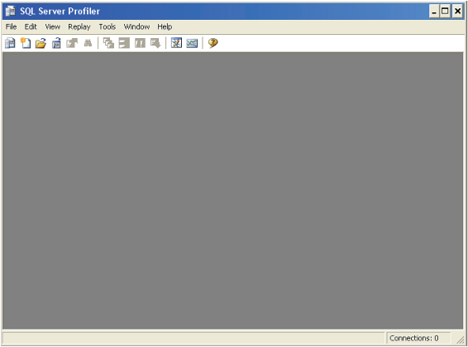

Figure 2-6: This is where we always start when creating a new trace.

### STEP 2: CREATE A NEW TRACE DEFINITION

Next, select **File** 🡪 **New Trace**, then log on to the SQL Server instance you want to practice with. Once you have logged, the Trace Properties screen appears.

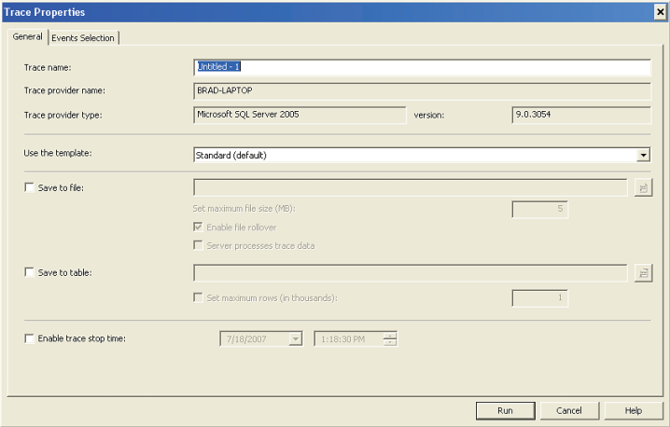

Figure 2-7: The Trace Properties screen is where we create new traces.

Now we can begin creating our own new trace. Next to “Trace Name” give this trace some name you will remember, such as **Profiler_Practice**, or whatever you prefer.

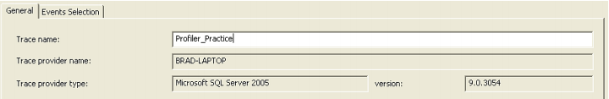

Figure 2-8: Enter a name for your first trace.

Next to “Use the template,” use the drop-down menu to select “Blank.” This tells Profiler that you don’t want to use a pre-existing template and that you want to set all the trace options manually. The “Blank” option is at the very top of the drop-down list, so you may have to scroll up to see it.



Figure 2-9: Select the “Blank” template.

### STEP 3: SAVING THE TRACE TO FILE

Up to this point, we have not done much different from before. Now it is time to do something new. In Chapter 1, as we were running the trace, the data was stored only in RAM, which is the default behavior. Only after the trace was complete did we save the results to file.

For this new trace, we want Profiler to store the results in a physical file on a local hard disk, as well as in RAM, as the trace data is being collected. As you gain more experience with Profiler, you will find yourself wanting to save trace files, and specifying this now can save a little time.

|  |
| --- |
| **Note**  A little later in the chapter, I’ll show you how to save a trace directly to a database table (although this is not recommended, because of performance issues). |

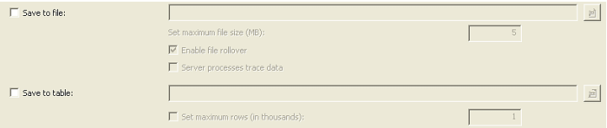

Figure 2-10: Automatically saving a trace to file.

To tell Profiler that you want to the trace to be automatically saved as a trace file, select the option “Save to File.” When you click on this option, you immediately get a “Save As” dialog box:

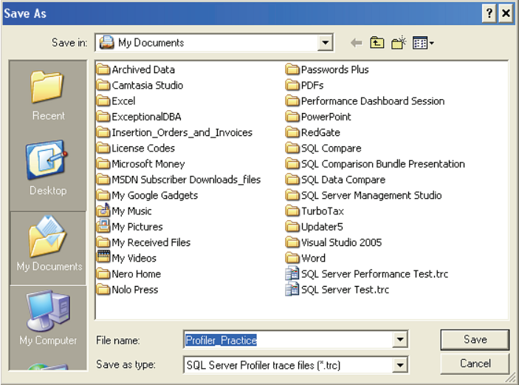

Figure 2-11: You have to tell Profiler where to store the trace file.

By default, traces are stored under “My Documents”. If you would prefer to store traces somewhere else, that’s fine. Notice that the “File Name” for the trace is the same name you assigned the trace. You can use this name, or choose a different name, whichever option works best for you. In addition, trace file have a .trc extension. While the file format used to store trace data is proprietary, it is an efficient way to store traces. We can, as we will discover later, convert the trace data into different formats, but for now, we will stick with the .trc format, which works well.

Once you assign the trace file a name, you are returned to the Trace Properties screen, which now looks slightly different,

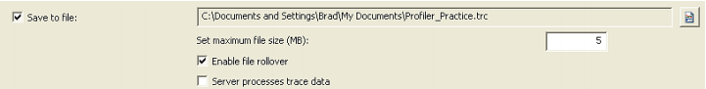

Figure 2-12: Once you choose to save a trace file, you have several options to choose from.

The first option you have available is to “Set maximum file size (MB).” The default value is 5MB. Depending on how busy your server is, and how many events and data columns you are collecting, it doesn’t take long for a trace file to get huge. This option allows you to control the size of the saved trace file. You can choose any file size you want, up to the available space on your disk.

The next option, “Enable file rollover” is directly related to the “Set maximum file size (MB).” By default, this option is selected. What this means is that when your trace file reaches 5MB (or whatever size you specify), a new file will be created to store the trace data. The new file name will be the original .trc filename with a number appended to it, such as Profile_Practice_1. This rollover effect will continue until you stop the trace or you run out of disk space. If you don’t select this option, the trace will automatically stop when the maximum file size you specified is reached.

As a DBA, you must decide what the best compromise is between file size and file rollover. For now, I suggest you accept the defaults. When you have gained some experience, you will be in a better position to be able to determine what values work best for you.

However, be warned: when you begin practicing using Profiler, carefully watch the size and quantity of your rollover files. Depending on your server, you can create a lot of data very quickly, much faster than you might expect. You don’t want to receive a nasty “Out of Disk Space” error. And one more tip: be sure to delete traces once you no longer need them. Again, they can take up a lot of disk space, potentially causing you future problems.

The next option is called “Server process trace data,” which we will save for the next chapter, as it is an advanced option.

### STEP 4: SELECTING THE EVENTS TO TRACE

When I create a trace, the first thing I like to do is to select the events I want to capture. Since this is a practice trace, we don’t want to select a lot of events. Our goal is learn the overall picture now, and we will focus on specific details later in this book. For our practice example, let’s assume that we want to trace all Stored Procedure events. In order to select these events, we have to click on the plus sign next to the “Stored Procedures” event category, and the events specific to stored procedures are displayed on the screen. See Figure 2-12 below.

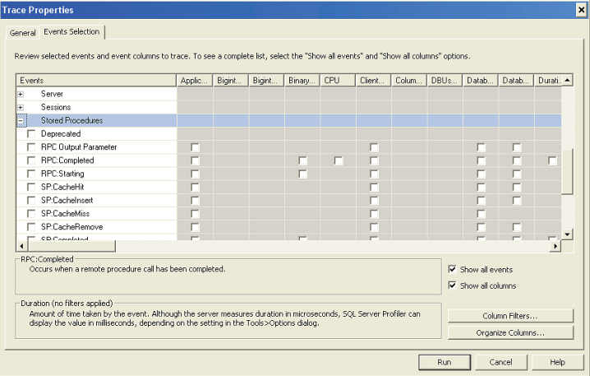

Figure 2-13: Selecting specific events to trace.

As you can see, the “Stored Procedures” event class has many specific events associated with it. In addition, you can see from the figure above that there are different data columns associated with each event.

To capture all the Stored Procedure events in the Stored Procedures category, click on each of the events as shown below. Not all are displayed on the screen, so you will need to scroll down a little to view and select them all.

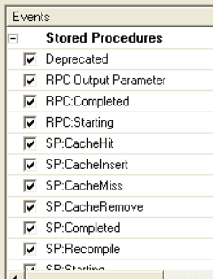

Figure 2-14: We have elected to trace all stored procedure events.

Essentially, that is all there is to selecting events to trace. You can select as many events as you want, although I should warn you that the more you select, the more data you collect and the more SQL Server resources you consume.

### STEP 5: SELECTING THE DATA COLUMNS

Now that we have selected the events we want to trace, our next step is to select the data columns associated with the events we want to capture, for which we want to collect and store information. As you select your desired events, every data column available for that event is automatically selected.

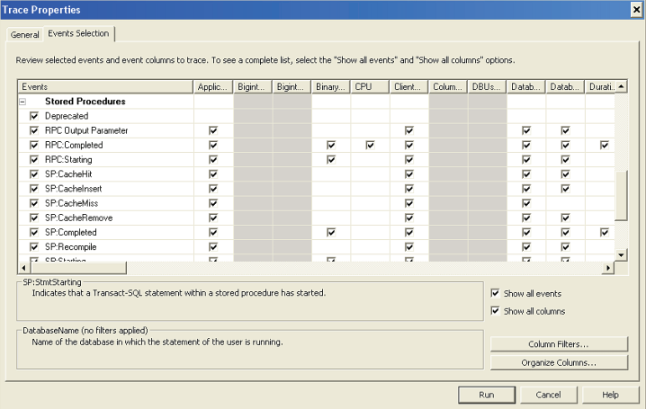

Figure 2-15: By default, when you select an event, all the data columns associated with that event are automatically selected.

While you can leave them all selected if you want, it is always a better choice to only select those you need, in order to minimize resource overhead. This means you need to deselect columns you don’t need.

However, to keep things simple for this example, let’s keep all of the data columns selected. We will learn later in the book which data columns are best selected, and which data columns are best not selected.

### STEP 6: APPLYING FILTERS

Now we enter new territory. We are going to learn how to apply a filter to a trace. Remember, a filter is a way to reduce the number of events we collect in a trace. For example, if we only want to collect trace events for a single connection, or for a single database, we can do simply that. This reduces the amount of data that is stored in our trace. Using filters is optional, but very useful when isolating what data is collected during a trace.

To add a filter to a trace, click on the “Column Filter...” button, and the “Edit Filter” screen appears.

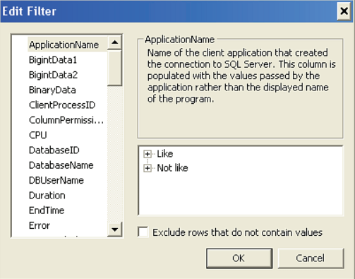

Figure 2-16: Select which trace events to capture using this screen.

On the left-hand side of this screen, you see all the available data columns for all events you previously selected. On the right-hand side you see where you can add criteria to filter which events are selected and which are not.

You can apply a filter to any of the data columns available. A common filter column is DatabaseName, in order to collect events only from a given database, or to exclude other databases. For example, if Reporting Services is installed on the server you are profiling, you may find that you often use a “Not like ReportServer” filter on the DatabaseName column, in order to prevent your traces being cluttered with events fired on the ReportServer database.

In our practice example, let’s choose a filter on the Duration data column, so that we only capture those events that have a duration longer than 100 milliseconds. This way, we filter out very short-running events and only see events than take more than 0.1 seconds to execute. To do this, select the Duration data column and enter 100 in the “Greater than or equal” box.

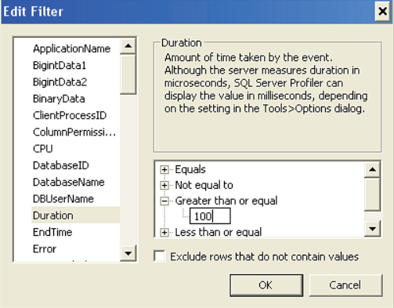

Figure 2017: We have just added a filter based on the duration data column.

Once you have specified a filter, you can continue to add more. In our case we are done, so we click on “OK” and the filter has been saved for this trace. To verify this, you can click on the “Column Filters...” button again, and you’ll see a filter icon next to the Duration column (not shown).

### STEP 7: ORDERING THE DATA COLUMNS

Now that a filter has been added, our next step is to select the order in which we want the data columns to be displayed when the trace is run, and to specify whether we want to group events according to a given data column. This is an optional step, but one that you will find quite useful for many traces.

To organize columns, click on the “Organize Columns” button, and the following screen appears.

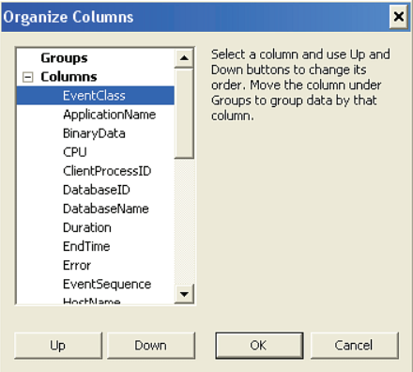

Figure 2-18: The Organize Columns screen

By default, when the Organize Columns screen appears, there is no grouping by events, and data columns are sorted alphabetically, with the exception of EventClass, which always appears first. If you wish to change the order in which the columns are displayed, simply select an event and click the “Up” or “Down” buttons.

For our practice trace, let’s say that we want to group events by Duration and leave the remaining data columns in their default order. To group by Duration, click on Duration on the screen, and then click on the “Up” button until it moves up under “Groups,” as shown in Figure 2-18:

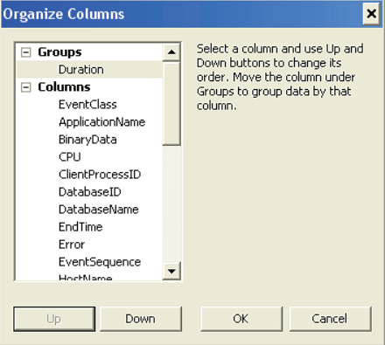

Figure 2-19: With the above setting, captured events will be grouped by duration.

Once you have completed this step, click on OK to return to the Trace Properties screen. Can you believe it, we are now done creating our practice, and it is ready to run. So let’s run it.

### STEP 8: RUNNING THE TRACE

To run your new trace, click on the “Run” button at the bottom of the screen, and the trace begins. You will see a screen similar to the one below, except that your events will look different, as I am using a different database and application than you are. If the server you are monitoring is not being accessed by stored procedures, or if all of them are faster than 0.1 seconds, or if your servers are not doing much, you won’t see many results (because of the events and filter we selected). On the other hand, you may be seeing hundreds of events being collected very quickly. It all depends on your server’s current workload.

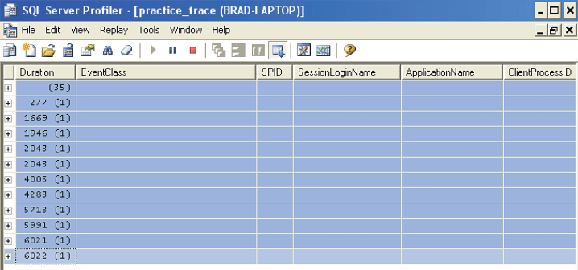

Figure 2-20: This is what a running trace looks when it is grouped by duration. If you don’t group by duration, the screen will look different, as we will see later.

In figure 2-20, you see that events are sorted by duration, with the shortest running events shown at the top, the longest running at the bottom. The first figure in the Duration columns is the elapsed time in milliseconds and it is followed, in brackets, by the number of events that ran in that duration.

The first row shows 35 events with appears to be no duration. This is not really true. Some events don’t have a specific duration. They occur, but their duration is not measured. Because of this, they have a duration of NULL and they show up at the top of the screen without any apparent duration.

After that the actual events, you must click on the plus sign next to the row you want to examine. Let’s start with clicking on the 35 events with a NULL duration.

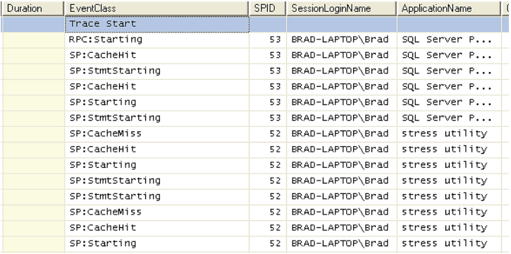

Figure 2-21: The above events don’t have a discrete duration.

While I don’t want to get into a lot of detail now, you can see that some of the events above represent a stored procedure being executed, and show whether its execution plan was found in SQL Server’s buffer cache.

Let’s now take a look at one of the discrete events that were captured:



Figure 2-22: Here is an example of a stored procedure being complete. Note that the duration of this stored procedure execution was 277 milliseconds.

In the above figure, we see that a particular stored procedure ran for 277 milliseconds. Because of the small size of the screen, I can’t show you all of the data columns. But if you are following on your computer, you can scroll oversee all the various data columns that have been collected.

### STEP 9: STOPPNG THE TRACE

Once you’ve collected enough data, stop the trace by clicking on the “Stop Selected Trace” icon.

Congratulations, you have now created and run your first trace. At this point, you would usually review the collected trace data to identify whatever issue you were looking for. Once you were done, you would exit Profiler. Because we gave the trace a name and saved it as a trace file, this file has automatically been save on disk for us at the location previously specified.

So, if you exit Profiler now, Profiler will exit, but the trace you made is still saved and can be viewed any time you like by selecting File | Open | Trace File.

If you are done analyzing your trace, you can either archive the trace (store it somewhere so that you can find it again) or delete it to save space.

## SAVING TRACES TO A SQL SERVER TABLE

Until this point, we have only talked about saving Profiler traces directly to disk. There is a good reason for this, and that is performance. For the least impact of using Profiler, traces should be originally stored on disk using the standard Profiler file format.

Is this the only option? No. Profiler also allows you to store a Profiler trace directly into a SQL Server table (see Figure 2-5), bypassing a disk file entirely. While this option works fine, it puts a lot of overhead on SQL Server that can negatively affect SQL Server’s performance. Because of this, saving a Profiler trace directly to SQL Server is not recommended.

Now you ask, what if I want to store my Profiler traces in SQL Server, not only for the ease of querying the data, but to store it in order to maintain a baseline of Profiler activity? That’s not a problem. Instead of saving Profiler trace data directly to a SQL Server database later. While this is an extra step, it is necessary if you don’t want to hurt the performance of the production SQL Server instances you trace.

Within the SQL Server Profiler GUI, it is very easy to save a Profiler trace to a SQL Server table. To begin, you have to have a trace loaded into profiler. To save this file into a SQL Server table, go to the Main menu and select File | Save As | Trace Table.



Figure 2-23: Profiler traces can be save in SQL Server tables using the Trace Table option

Once you select this option, a new window appears (see figure 2-34 below) prompting you to log into the SQL Server instance where you have the database containing your Profiler traces.



Figure 2-24: Log into any SQL Server instance where you want to store Profiler traces.

Next, you must specify the name of a pre-existing database where you want to store the trace table (see figure 2-25 below). Ideally, you should have a database designed for this specific purpose. In addition, you have to assign the trace table a name. Give it a name that makes it obvious what it is so you can find it later.



Figure 2-25: Select the database where you want to store Profiler traces.

Once you click the OK button, the file is automatically moved from Profiler to the database. A new table is automatically created for you, and the data stored in it.



Figure 2-26: This is what the trace looks inside a SQL Server table.

Once the data has been stored in a SQL Server database, you can access the data just as you would with any other SQL Server data. Many DBAs create their own scripts to analyze the data; others use Reporting Services to create custom reports.

## CAPTURING ANALYSIS SERVER TRACES

The focus of this book is on administrative DBAs who work with the SQL Server engine, not Analysis Services. However, starting with SQL Server 2005, DBAs do now have the ability to capture Analysis Service traces, and the process is very similar to the one we’ve just seen, so what have already learned can be reapplied here.

To start an Analysis Services Profiler trace, start Profiler and select File | New Trace, just as you do create any trace in Profiler. The only differences is that you select Analysis Services as the Server type:



Figure 2-27: When you start an Analysis Services trace, you must select the appropriate server type.

After you select the appropriate server and login information, click on “Connect” and the Trace Properties screen appears:



Figure 2-28: Gee, this screen looks familiar

As you can see, the General tab is identical to what we have see before. The only difference is that there are only two built-in templates, plus the blank template available.

Let’s choose the Blank template and click on the “Events Selection” tab.



Figure 2-29: The “Events Selection” tab above works just like the “Events Selection” tabs we have seen throughout the entire book.

After first glance, this screen looks very similar to the “Event Selection” tabs we have already seen. In fact, it works identically, but what is different is that Analysis Services has its own set of unique events and data columns, distinct from the database engine, so in fact this is an entirely different world that we have not see before.

We are confronted with 11 Event Categories, 42 events, and 32 data columns. There is enough material here for another book, and that’s why we won’t be discussing any of the details of the events and data columns available for Analysis Services.

However, all other aspects of using Profiler are identical so, if you want, you can use what you already know to start experimenting with Analysis Services traces and see how they can help make your data warehousing projects perform better.

## CREATING AND USING TRACE TEMPLATES

Now that you know how to create your own trace, it’s time to explore further the idea of trace templates. As you might expect, creating custom traces can be a lot of work, especially if you take the care to select only those events and data columns that you really need, apply the appropriate filters, organize the columns as you want them, and so on.

Once you’ve taken the time to define a trace exactly as you want it in order to investigate a certain SQL Server issue, you certainly would not want to have to go through all that work again next time the issue arose. Instead, you will want to save your custom trace as a trace template, so that you can run it again and again, as required.

Fortunately, Profiler provides a variety of built-in (predefined) templates, and also allows you to define you own. We’ll start our investigations with the former.

### PREDEFINED PROFILER TEMPLATES

From the General tab in Profiler, you can click on the down arrow of the “Use the Template” dropdown box to see all the available templates:



Figure 2-30: Predefined Profiler templates are listed.

Profiler comes with eight predefined templates for the Database Engine, plus the blank template. At first glance, you may or may not be able to guess what some of these templates are designed to capture. To be honest, until I played with each template, I couldn’t figure out what each one was really designed to do, as the template names are not obvious.

To learn how to use predefine templates, we don’t have to take an in-depth look at each one. What I want to do is to talk about the first two templates in some details, so you fully understand the concepts behind templates. The last six templates will then only need a brief mention.

#### STANDARD(DEFAULT)

This template capture six different events in four event categories: Security Audit, Sessions, Stored Procedures, and TSQL. It also includes many different data columns, many of which are not included in this screen shot because there is not enough room to show them all.



Figure 2-31: The Standard (default) template collects a wide variety of information.

As you might expect from a fairly complex, general purpose template, the resulting trace (below) can be reasonably complex.



Figure 2-32: A small sample of the events captured by the default trace template.

So why might you use this template? First, it lists all the currently existing connections to the server instance you are monitoring. In my example, there is only one connection. Second, it lists audit events, showing you when SQL Server Login IDs have logged into and out of the server. Third, it captures stored procedure execution. Fourth, it captures T-SQL statements that are not part of stored procedures. In the data columns, you also see a little bit about the resources used by each event, which can help tell you how each event has affected the instance’s resources. Oftentimes, I use this template when I want to do a “quick and dirty” profile without having to put a lot of thought into selecting what specific events or data columns I want to collect. This template identifies many common performance-related issues, and is a good starting point.

#### SP_COUNTS

This template is very different from the Standard template, including fat fewer events and data columns. A point I want to make now is that templates can be very different from one another.

This simple template is designed to capture information whenever a stored procedure is first started. The results are then sorted by EventClass, ServerName, DatabaseID and ObjectID. This way, once the output has been collected, it can be sent to a SQL Server database where you can then perform a Transact-SQL count on the ObjectName in order to count how many times each stored procedure ran during the trace period.

For example, as you can see from the screen shot below, this template captures a single Event: **SP:Staring**.



Figure 2-33: Events captured with the SP_Counts Profiler template.

The screen shot below shows a trace generated by the SP_Counts Profiler template.



Figure 2-34: An example of a trace produced by the SP_Counts Profiler template.

So how might you use this template? Let’s say that you are interesting in identifying the top most run stored procedures in your application. By running this trace, and through a little Transaction-SQL code, you can produce a report showing how many times each stored procedure ran during the trace period.

Now that you have seen a little detail about two of the predefined Profiler templates that come with Profiler, let’s take a quick look at what the remaining templates do.

#### TSQL

This template is used to capture all T-SQL statements that are submitted to SQL Server by clients, along with time stamps. This might be used by developers to debug client applications.

#### TSQL_DURATION

The TSQL_Duration template is used to capture all T-SQL statements submitted to SQL Server by clients and their execution time. It groups the results by execution time duration. This template is often used to identify slow queries.

#### TSQL_GROUPED

This is used to capture all T-SQL statements submitted to SQL Server and the time they were submitted for execution. In addition, the statements are grouped by the user or client that submitted the statement. This is often used to investigate problem queries from a particular client or user.

#### TSQL_REPLAY

This is used to capture the appropriate events and data columns about T-SQL statements so the trace can be captured and later replayed back to SQL Server. This is often used to for iterative turning benchmark testing, or stress testing.

#### TSQL_SPs

This template captures detailed information about all executing stored procedures. It is often used to analyze the statements within stored procedures.

#### TUNING

This template captures information about stored procedure and T-SQL batch execution. This trace can be used as the raw data to feed into the Database Engine Tuning Advisor for index optimization.

As you can see, these templates are fairly limited in scope, but they are often a good starting place for a novice Profiler user. As you gain more experience, you will tend to skip these templates and create your own.

### CUSTOME PROFILER TRACE TEMPLATES

As we’ve seen, a custom trace is one where you define the events and data columns to collect, the filters to apply and so on. A custom trace template is essentially the same thing, but you have the ability to reuse it again and again, without having to repeat all this work. So, if you think about it for a moment, every trace you create, apart from the very simplest, should be a custom trace template!

In this section we will be taking a look at the following topics:

* How to create a Trace Template from scratch
* How to create a Trace Template from a running trace
* How to create a Trace Template from a saved trace file or trace table
* How to modify a Trace Template
* How to execute a Trace Template
* How to import and export Trace Templates

#### CREATING A CUSTOM TRACE TEMPLATE FROM SRATCH

Creating a trace template is as easy as creating a custom trace, although you use different Profiler options. To begin creating a trace template, from the Main menu, select File | Templates | New Template, as shown in figure 2-35:



Figure 2-35: Select “New Template” to begin creating a new template.

After selecting the “New Template” option, the Trace Template Properties screen appears:



Figure 2-26: Creating a template is very similar to creating a custom trace.

This screen is very similar to the “Trace Properties” screen we see when we create a custom trace. There are two tabs: “General” and “Events Selection.” While the “General” tab is slightly different from the “Trace Properties” screen, the “Events Selection” tab is identical.

Let’s have a look at the “General” tab first. At the top of the screen is a drop-down box called “Select server type”:



Figure 2-37: when you create a trace template, the first step is to choose the type of trace.

As you can see in figure 2-37 above, this option allows you to specify what kind of instance the trace will be running against. You need to make this choice because it affects the events and data columns that will be available on the “Events Selection” tab.

Next to “New template name” you enter the name of the template. Be sure to give it a descriptive name that not only you, but other DBAs, will be able to understand.

If you like, you can create a new template based on an existing one. To do this, check the “Base new template on existing one” checkbox and then select the predefined template you want to use as basis for your new custom template.

If you want to make your custom template the default Profiler template for the selected Server type, you can do this by checking the “Use as a default for selected server type.” The default Profiler template refers to which template is displayed, by default, next to “Use the template” from the “Trace Properties” screen. Generally, I don’t bother with this option because I end up selecting some other template other than the default on listed on the screen.

Once you have made your choices (only the first two are required), click on the “Events Selection” tab.



Figure 2-38: this screen is identical to then “Events Selection” tab we have used many times before.

Now you are ready to create your trace, selecting the events and data columns you want, including setting column filters and organizing columns, just you did before. Once you are done, click on “Save” to save the template. The template will be saved and will available from the “Use the template” dropdown box on the “Trace Properties” screen.

#### CREATE A CUSTOM TRACE TEMPLATE FROM AN EXISTING OR SAVED TRACE FILE

Above, we discussed how to create a trace template from scratch. There are two other ways to create this template. One is to take a currently existing trace (loaded in Profiler, but not running) and convert it into a trace template. The other way is to load a pre-existing trace file from disk into Profiler, then create a trace template from that.

Let’s say that you have create a custom trace (not a trace template) as we did earlier in the chapter, and are looking at the results on the Profiler screen. It is doing exactly what you need, but you did not create this originally as a template. Is there any way to save all this work as a template without having to create a template from scratch?

Yes. From the Main menu, select File | Save As | Trace Template, as you see in figure 2-39.



Figure 2-39: You can save a trace template by using the “Save As Trace Template” option.

Then the following screen appears, where you enter the name you want to assign to the template. After you have entered the new template name, click on OK and the trace is saved. See figure 2-40.



Figure 2-40: name the new template.

If you want to create a customer template from a trace file previously saved to disk, simply open the trace in Profile (File | Open | Trace File) and follow the same steps.

If you had saved the file to a SQL Server database table instead of a file, you can also load it into Profiler by selecting File | Open | Trace table, which will allow you to select the table you want to load, and it will load into Profiler for viewing. At this point, you can save the file as a new template, just as in the previous example.

Sometimes, when you follow the above procedure and try to select File | Save As | Trace Template, the option will grayed out, preventing you from saving your existing trace as a Trace Template. This can be caused by one of two things. First, be sure the existing trace has been stopped, and it not running. You cannot save a race template of a running trace.

If this hasn’t fixed the problem, then go to the Main menu and select View, and either “Aggregated View” or “Grouped View” will be selected. Deselect whichever option is selected. Now, to back to File | Save As | Trace Template, and try again. This time, it will not be grayed out and you can save the template. For whatever odd reason, you can’t save a trace template unless both of these options are turned off.

#### MODIFYING CUSTOM TAMPLATES

If you decide later that you want to modify your custom template, this is also an easy task. Go to the Main menu and select **File** | **Templates** | **Edit** **Template**.



Figure 2-41: You can edit a Profiler template at any time.

Once you have made this selection, the following screen appears.



Figure 2-42: you can edit any template you want.

To select a template to edit, first choose “Select server type” for the type of template you want to edit. Notice that specific templates are associated with specific server types. This makes sense as each server type offers different Profiler trace events and data columns.

Once you have selected the server type, click on the “Select template name” drop-down box to select the template you want to edit. Notice in the drop-down list shown above (figure 2-42) that templates you create are labeled as “User” and that default templates that come with Profiler don’t have any designation.

Once you have selected the template to edit, click on the “Events Selection” tab, where you can modify the template to your liking. When you are done modifying then template, save it by clicking on the “**Save**” button.

#### EXECUTING CUSTOM TRACE TEMPLATES

We execute custom-made templates like we would any template; simply select your custom template from the “Use the template” dropdown on the General tab.

If you like, you can modify a trace before you execute it. All you need to do is to go to the “Events Selection” tab and make any changes you want. These changes will not be saved to your template, and will only be in effect for this trace.

#### IMPORTING AND EXPORING TRACE TEMPLATES

Once you have created many useful Profiler templates, you may want to share them with other DBAs. Or, perhaps, other DBAs have created trace templates that they have given to you for you to use. While you can locate the trace files on your computer and just copy them, it is easier to use the built-in features of Profiler that allows you to export and import trace template files.

To export a trace template, from the main menu of Profiler, select File | Templates | Export Template.



Figure 2-43: You can easily import and export Profiler trace templates

Next, the following screen appears.



Figure 2-44: you can only export or import one template at a time.

Here, selecting the template you want to export. Notice that you can only export one Profiler trace template file at a time. When you click on “OK,” you are presented with a standard save screen, where you are able to choose the path where you want to export the trace file.

If you want to import a trace file, select File | Templates | Importing Template, and you are presented with a standard open screen, where you can select the template you want to import.

## SUMMARY

Having read this chapter, you now understand the basics of creating your own custom traces; you also know how to save them to file and subsequently to a database table for further analysis.

You have appreciated the advantages of creating reusable trace templates, either from scratch or based on existing pre-defined templates.

In the next chapter, we take a look at some tips and tricks that will allow you to use Profiler more efficiently. Once you master this chapter, you will know about every feature and option in Profiler. Then you will be ready for the rest of the book, where we focus on how to apply Profiler to our daily jobs as a DBA.

# Chapter 3 PROFILER GUI TIPS AND TRICKS

By this stage in the book, you should have a good idea about what Profiler can do and how it works. Up to now we’ve tackled the GUI in a fairly “narrow” fashion, covering only those features that were directly necessary to us to achieve our goals of creating basic custom traces, template and so on.

There are quite a few options that we didn’t cover, however, and quite a few tips and tricks that, once you know about them, can really help you use Profiler more efficiently.

So, in this chapter, we cover these topics:

* Tips on Selecting Profiler Events and Data Columns
* Tips on Using Column Filters
* Tips on Organizing Columns for Grouping and Analysis
* How the “Server processes trace data” Option Affects Traces
* How to Set Global Trace Options
* How to Schedule a Trace’s Stop Time
* How to use the Auto Scroll Window
* How to Search for Data Inside a Trace File
* How to Set and Use Bookmarks

So let’s get started.

## TIPS ON SELECTING PROFILER EVENTS AND DATA COLUMNS

In the previous chapter, you learned how to select events and data column is order to create a custom trace. This is a straightforward process and is more or less self-evident. The problem is not in the mechanics of selecting events but in deciding which of the 170 Profiler events and 64 data columns that really want to select and in making sure you haven’t inadvertently included extraneous events and columns.

Our focus here is on tips and tricks to help you select which profiler events and data columns to capture in a trace.

### TIP#1: DON’T OVERLOAD YOUR TRACES

There is no easy way to decide which events or data columns you need to capture as part of a trace. It depends on the problem at hand, and it requires a good understanding of what events are available and what each one of them does.

**NOTE:** We cover specific events and data columns in some detail in *Chapter 11, Profiler Events and Data Columns Explained*.

Your first inclination as beginner will probably be to select more events and data columns than you need. This is very reasonable thing to do because the only real way learn about them, and especially how they apply to your SQL Server environment, is to experiment. I encourage you to experiment with different events and data columns, but with caution. Keep the following things in mind:

* Experimenting with too much data makes it hard to analyze the results. In other words, traces become very difficult to read if you collect too much data. You may get so overwhelmed that you become discouraged from wanting to learn how to master Profiler. For example, who would want to wade through several thousand Lock events(see Figure 3-1)?
* Returning too much data can put a performance hit not only on the SQL Server instance you are tracing, but on the local computer you are using to perform the trace.
* If, for some reason, you do need to collect a large number of events in a single trace, at least limit the length of the trace to a short period, say five minutes or less. This will allow you to collect a wide range of data, while at the same time not overwhelming resources.

So whether you are experimenting, or you are running actual traces, don’t get carried away with collecting too much data. As you gain more experience with using Profiler, this will become easier and easier for you to do.



Figure 3-1: If you capture too many events, you can get lost, trying to make sense out of events that aren’t really important. Who wants to see 5,000 **Lock:Acquired** and **Lock:Released** events?

### TIP#2: EVENT CATEGORIES ARE A GUIDE ONLY

As we have already discussed, individual events are divided into categories of similar events. The purpose of this is to allow you to more easily locate the events you are looking for. However, it is not designed as a short cut to help you identify which events to select. For example, if you wish to diagnose a problem with a slow performing query, you might be tempted to assume it’s as simple as selecting all the events in the Performance event categories. Rarely would you find yourself selecting all the events in a single event category (except those, of course, that only have one event associated with them).



Figure 3-2: Don’t be tempted to select all of the events within a given event category. You will only end up selecting events of little use, and missing other events that are important to your analysis.

### TIP#3. DESELECT UNWANTED DATA COLUMNS

As we noted in Chapter 2, when you select an event, all the data columns for that event are automatically selected. In most cases, you will want to select only limited data columns, not all of them, meaning that you will have to deselect those data columns from the events you don’t want.

A common mistake is to accidentally leave unneccssary data columns selected, and therefore clutter the resulting traces with unwanted data. In fact, the Profile GUI offers you a helpful visual clue that can help you avoid this situation. Take a look again at Figure 3-2. You may not have noticed it at first, but there are two data columns in that figure that are empty, and grey in color. Every other column in the figure is selected for at least one event, and is white in color.

In other words, a white column is visual cue to you that a data column has been selected for at least on event. So how is this helpful? Let’s say that you are creating a new trace and have selected about a dozen events, as seen in the figure 3-7 below.



Figure 3-7: Often, you can’t see all the events you selected on the same screen without scrolling through all of them.

As you select each event, every data column is selected for that event. However, let’s say that you want to deselect the Database ID data column for all events, because it essentially duplicates information in the DatabaseName column. So, you deselect the DatabaseID column for every event you can find, as show in Figure 3-8:



Figure 3-8: After deselecting all the DatabaseID checkboxes, the column is still white.

What you will notice is that the column is still white. This is an immediate indication that there are still some events for which this column is selected:



Figure 3-9: I guess I didn’t unselect all the events after all.

This visual cue can be very helpful when creating complex traces and when you want to ensure that you don’t collect more data than you intended. Once you’ve deselected the column for the rogue events that you missed, the screen should look as shown in Figure 3-10:



Figure 3-10: The grey columns tell us that no events haven been selected for this data column.

In actual fact, Profiler offers a second visual clue that can help you spot events for which all data columns are still selected. Did you spot it? Take a close look at the checkboxes to the left of the event names, in Figures 3-9 and 3-10. In Figure 3-9, the first five rows have a grayed-out check and the remaining events have a black check. If you see a black check, it means that all the data columns for that event have been selected. If you see a grayed-out check in the checkbox, it means that at least one of the data columns have been unselected. This can be useful to know as you create complex traces.

One more tip. If you want to select or deselect all the data columns for all the events listed on the Events Selection screen, right-click on the data column heading and choose either “**Select Column**” or “**Deselect Column**.”

### TIP#4:USE SHOW ALL EVENTS AND SHOW ALL COLUMNS

I mentioned this briefly in Chapter 2, but it’s worth emphasizing again here. When you create a new trace, the easier way is to start is with the Blank template, with the Show All Events and Show All Columns text boxes selected.

However, once you have selected the events and data columns you want, the screen soon becomes hard to read because it still shows events and data columns you did not select. In addition, since the size of the screen is limited, you can’t see all the events you selected without scrolling up and down the screen. See figure 3-12 below.



Figure 3-12: This Profiler screen makes it hard to see what events have been selected.

Once you have selected the events and data columns you want, it is much easier to see what you have selected if you deselect the Show All Events and Show All Columns checkboxes. When you do this, you only see those events and data columns, as shown in figure 3-13 below.



Figure 3-13: Now it is easy to see what events and data columns I have selected.

If you decide later to more events or data columns, you can easily check the Show All Events and Show All Columns checkboxes, makes the changes you want, and then deselect the Show All Events and Show All Columns checkboxes again. If you have many events selected, you still may have to scroll to see them all, but it is still a lot easier than scrolling through 150+ events.

### TIP #5: WHEN CREATING TRACES, YOU CAN ONLY CHANGE THE COLUMN ORDER USING ORGANIZE COLUMNS

As you select the data columns you want to capture for each event, it would often be handy to move the data columns in a different order. Unfortunately, you can’t click and drag column from on location to another. If you want to rearrange the columns on the screen in any order other than alphabetical order, you have to do so by using the Organize Columns button on this screen. If you click on any of the data columns head, thinking you might be able to drag and drop them, or even to change the sort order of the events (which you can’t), a box pops up that can be a litter can be a little disconcerting.



Figure 3-14: The Edit Filter window appears whenever you click on the name of any data column.

Clicking any of the data column names is the same as clicking on the Column Filters button. If you do this by accident, click “Cancel” to get rid of the screen.

However, note that once you are actually running a trace, then you can move the data columns into a different order, just by dragging and dropping.

### TIP #6: THE SPID AND EVENTNAME DATA COLUMNS ARE MANDATORY

Let’s say that you don’t want the SPID data column to be captured for a given event and try to unselect it. It will produce an error message as in figure 3-16.



Figure 3-16: The SPID data column is required.

Of all the data columns, two are required and must be included in every trace. One is EventName, which is not even listed on the Events Selection screen, and SPID, which is listed. It seems a little odd that one required data column is not even shown, but that is the way Profiler has been designed, so just be aware of this peculiarity. You will see both the EventName and SPID column when you run a trace.

### TIP #7: USE THE HELP TIPS!

You have probably already figured this out, but just in case you haven’t, if you hover the mouse pointer over any event or data column name, you will see a help tip at the bottom of the screen.



Figure 3-17: Tooltips are available for all events and data columns.

In figure 3-17, I hovered my mouse pointer over the checkbox that intersects the event RPC: Completed and the ServerName data column. This way, I get two tooltips: one for the event and one for the data column. Or, you can just hover over the event or data column name to see a tooltip.

## TIPS ON USING COLUMN FILTERS

Filters are a powerful tool because they allow you restrict which events are captured and which are exclude. For example, if you have selected the SQL:StmtCompleted event as part of your trace, you may only want to see Transact-SQL statements from a single database only, not from all the databases on your server. This is easily accomplished by creating a filter to limit the events to be captured to those that occur only in the database you select, not events occurring on other databases on the same SQL Server instance.

In this section, we look at some tips to help you make the most of this feature.

### TIP #1: EDITING FILTERS

There are two different ways to display the Edit Filters window, which is used to add, modify, or remove column filters. The easiest option is to click on the Column Filters button. The other way is to click on any column name on the screen. If you choose the latter method, the column name you selected is automatically selected for you in the Edit Filters window.



Figure 3-18: The Edit Filter window is used to create, modify, or remove column filters.

In figure 3-18 above, I clicked on the **DatabaseID** data column on the Events Selection tab of the Trace Properties screen and Edit Filter window appeared, with DatabaseID preselected for me.

## TIP #2: FILTERS DO NOT NECESSARILY REDUCE WORKLOAD

Many DBAs assume that by creating filters for a Profiler trace, that they are substantially reducing the workload on SQL Server. The assumption is that if you are collecting fewer events because you have added filters, that the workload should be less. Unfortunately, this assumption is often not true.

Here is what is happening. When you select an event for SQL Server to trace, SQL Trace (the SQL Server component that actually does the tracing work) has to look at every event that is occurring in order to identify a particular event as one you want to collect. If you don’t add a column filter, then your trace will record data for every occurrence that event in your instance of SQL Server. This alone is a lot of work.

When you add a column filter, every event is still captured, but then SQL Server also has to decide whether to keep the event (and store in RAM and/or disk) or to toss it away.

But all is not lost. While the addition of a column filter does introduce additional CPU overhead, it does reduce the number of events that are stored in RAM and/or written to disk. This acts to reduce the amount of resources used to run Profiler. The hard part is gauging whether or not the extra resources needed to apply the filter are more, or less, than the resources saved by limiting the number of events collected.

### TIP #3: CREATING MULTIPLE FILTERS

When you create a column filter for a trace, you can filter on a single data column or on multiple data columns. Each time you filter on an additional data column, a funnel icon appears next to the data column you are filtering on.



Figure 3-19: Funnel shaped icons appear next to the data columns where you have set up specific filters.

As you add filter criteria to a data column, only click the OK button if you have finished adding filters for this trace. If you want create several data column filters at one sitting, create on filter, then press the TAB key to save the criteria, and then to proceed to add other filter criteria. Only when you are done should you click OK. If you click OK by mistake before you are done, the Edit Filter screen disappears, although you can still go back and change the filter; it just takes extra keystrokes.

### TIP # 4: FLTER CRIERIA

When adding filter criteria, keep the following in mind:

* Not all data columns can be filtered.
* Some data columns have different filter criteria than others. The available criteria are displayed for you, so you know what is available.
* You can use the % symbol as a wildcard for the TextData data column.
* The data you are filtering for has to exist. Not all data columns are always populated for the same event.
* If you filter on StartTime or EndTime data columns, use the format: YYYY/MM/DD hh:mm:sec.

### TIP5 #5: EXCLUDING EMPTY ROWS

At the bottom of the Edit Filter window is a checkbox that says, “Exclude rows that do not contain values.” This provides a way to filter out records that didn’t include any data for a specific data column.



Figure 3-20: The “Exclude rows that do not contain values” option is data columns specific.

When this filter is put into place, it only works on rows that have data columns that are actually empty. If there is a NULL value in a data column, the row will be returned. This option should not be combined with another filter for the same data column. If you try, the results may be unpredictable, due to a bug in the code that has not been fixed in SQL Server 2005.

## TIPS ON ORGANZING COLUMNS FOR GROUPING AND ANALYSIS

In chapter 2, we learned that the Organize Columns window allows you to perform two major functions:

1. Change the default order of the data columns on the screen
2. Group events based on a certain data column

This section covers some tips on how to make the most of these two features.

### TIP #1: WHICH ARE THE MOST IMPORTANT DATA COLUMNS?

While you can choose any order in which to display data columns, I recommend that you put the most useful events toward the left, and the less useful toward the right of the trace screen. This way, when you read and analyze trace results, you will have to perform less scrolling to see the data you want to see.

There is no way to say, definitively, which are the most important columns, because it will vary according to what you are tracing. However, some of the data columns that I like to put on the left side, because I use them a lot, include TextData, Duration, CPU, Reads, Writes, ApplicationName, StartTime, and EndTime.



Figure 3-21: You should order data columns in the order that is of most important to you.

### TIP #2: DATA IS ONLY AGGREGATED IF YOU GROUP ON A SINGLE COLUMN

If you decide to group rows by a data column, keep the following in mind:

* If you group a single data column, that data column will automatically be aggregated for you.
* If you group two or more data columns, the data will be sorted as you specify, but no aggregations are performed.

### TIP #3: CONTROLLING AGGREGATION AND GROUPING

If you have specified that data columns be grouped, or aggregated, inside of the Organize Columns window, and are currently capturing or displaying data in Profiler, you can turn of grouping and aggregation by going to the VIEW menu and selecting the appropriate option.



Figure 3-22: You can change the way events are grouped by selecting, or not selecting the Aggregated View or Grouped View options.

You can choose to turn off both Aggregated View and Grouped View, which means that all the data will be ungrouped and unaggregated.

If you turn the Aggregated View on and Grouped View off, then the results will be aggregated based on what data column you are grouping by.

If you turn the Aggregated View off and the Grouped View on, then all the results will be sorted on the data column you are grouping by.

For example, let’s say that I am going to run a trace, and that I have specified that I want to group data by EventClass. When I run this trace, I will see all the data automatically aggregated for by EventClass. This is the default behavior.

Then I decide to change the view Settings so that Aggregated View and Grouped View are turned off. In this case, the events are ordered in the order they actually occurred:



Figure 3-23: Both Grouped View and Aggregated View are turned off.

If I then decide to turn Grouped View on, but leave Aggregated View off, the data columns are sorted by **EventClass**:



Figure 3-4: Grouped View is turned on and Aggregated View is turned off.

If group View is turned off and Aggregated View is turned on, then rows are aggregated by EventClass. This returns us to our default view:



Figure 3-25: Grouped View is turned off and Aggregated View is turned on.

Keep in mind that this feature only works if already have an event under Groups in the Organize Columns window. In addition, you can switch between viewing modes as much as you like. What you can’t do is to change the event you are grouping. That can only be done before you start a new trace, not after the trace has been created.

## HOW THE “SERVER PROCESS TRACE DATA” OPTION AFFECTS TRACES

in the General tab of the Trace Properties screen, if you select the “Save to file” option, an additional option becomes available, called “Server processes trace data.”



Figure 3-26: The “Server processes trace data” option

When this option is selected, Profiler ensures that all events are recorded, even if this means that the SQL Server instance’s performance will be hurt. To accomplish this task, two separate trace processes are started that trace exactly the same events as each other. One trace process sends events to the Profiler GUI, and the other trace process sends the data to a local disk file. While this ensures that all events are captured, it also means that a significant burden may be put on SQL Server, hurting its performance. If the SQL Server instance is not busy, then the performance his is not a problem. But if the instance is very busy, then the performance hit could be significant.

If this option is not selected, then Profiler does not guarantee that all events will be captured, and only one process is used to capture events. This reduces the performance burden on SQL Server significantly. If the SQL Server instance is no too busy, then there should be no loss of events. But if the server is busy, and Profiler thinks that capturing all events would hurt the performance of the instance, then events will be dropped as needed to prevent a significant performance hit.

So, should you use this option or not? In most cases, you will not want to select this option. If your server is not too busy, then all events will be captured anyway. If the server is very busy, you most likely don’t want to add an additional performance burden to it. In most cases, missing some events won’t affect your analysis, so this is not a problem. In the rare case where you run into a situation where you have a busy server, but you can’t seem to find the events you need to resolve a problem because they are not being captured, consider turning this option on for short periods until you get the trace results you need. At the same time, ensure you are only collecting those events and data columns you really need, in order to reduce the performance hit as much as possible.

## HOW TO SET GLOBAL TRACE OPTIONS

SQL Server Profiler allows you to control some general settings that affect how Profiler performs. In this section, we look at these options and how they should be set.



Figure 3-27: The General Options screen allows you to affect some global Profiler behavior.

### DISPLAY OPTIONS

If you wish, you can change the font name and size used to display events in the Profiler trace window. By default, the font is Arial and the size is set to 8, which is about as small as you probably want to make it. If you want to make a change, click on the “Choose Font” button.

By default, date and time values displayed by Profiler use the fixed format used by SQL Server. if you want to use another format, you can select the “Use regional settings to display data and time values” checkbox, which will tell Profiler to use the regional date and time settings currently used by the OS.

In SQL Server 2005, duration is measured by Profiler in microseconds, but is displayed in Profiler in milliseconds by default. If you would prefer to see microseconds displayed instead of milliseconds in Profiler, select the “Show values in Duration column in microseconds” checkbox.

### TRACING OPTIONS

I am not sure why anyone would want to use this option, but if the “Start tracing immediately after making connection” checkbox is selected, then the Default trace template is started immediately when Profiler is started.

### FILE ROLLOVER OPTIONS

This option only applies when you load a pre-existing trace file for display by Profiler. By default, the option “Load all rollover files in sequence without prompting” is selected. This means that if you attempt to load a trace file that includes rollover files, then all the rollover files are loaded automatically in sequence. I prefer to use this option as it requires no extra keystrokes or mouse clicks to load a trace file.

If you choose the option “Prompt before loading rollover files,” then you will be prompted to load each rollover file; you can choose to load it or not.

If you choose the option “Never load subsequent rollover files,” this means that only the file you select is loaded, and other associated rollover files are ignored.

### REPLAY OPITONS

Replay options affect Profiler when you replay Profiler traces to a SQL Server instance.

The “Default number of replay threads” option determines how many threads are used to play back events. The default value if four, and should normally not to be changed. Increasing this value will use more server resources.

The “Default health monitor wait interval” option affects the amount of time that a thread is allow to run before it is turned off by the health monitor. The default value is 3600 seconds, or 1 hour. The main purpose of this option is to prevent any trace replays from talking longer than you expect, and hurting performance.

The “Default health monitor poll interval” specifies how often the health monitor polls replays so it can determine how long they have been running. The default value is 60 seconds, and should normally not be changed.

## HOW TO SCHEDULE A TRACE’S STOP TIME

Up to this point, we have been manually starting and stopping traces. While the SQL Server Profiler GUI won’t allow you to schedule the start of a trace, it will allow you to schedule the stop time of a trace.

NOTE:

In a later chapter, we will discuss how you use system stored procedures to stop and start traces using a SQL Server Agent job.

Scheduling a trace stop time is very easy. Start by creating a trace as you normally would. At the bottom of the General tab on the Trace Properties screen is an option called “Enable trace stop time”.



Figure 3-28: check the “Enable trace stop time” checkbox to schedule a trace to stop

Once you check this option, you can select a date and time for the trace to end automatically. After you start the trace manually, it will end at the time you specified.

The main thing you need to consider when using this option is how much data will you collect during this period, and will the storage location for the trace file have enough storage space for it? The last thing you want to do is to crash some system because you ran out of space. So don’t use this option unless you are comfortable that you system won’t run out of space. Otherwise, it is best to stick around during the trace, watching the size of the trace file to ensure it doesn’t get too big.

## HOW TO USE THE AUTO SCROLL WINDOW

When you are running a live trace and displaying the results in Profiler, you may have notice that the Trace window automatically scrolls to the bottom, showing you the most recent events that have been captured. If you use your mouse to scroll the window up to see an earlier event while the trace is running, as soon as a new event has been captured, the screen immediately jumps down to the most recent event. This can be quite irritating if your goal is to look at an older event while the trace is running. This default behavior is called **auto scroll**.

Fortunately, there is an easy way to turn this default behavior off, which allows you to scroll anywhere you want inside the window without having to worry about new events jumping the screen to the bottom. There are two options available to turn off auto scroll.



Figure 3-29: Going to Window | Auto Scroll allows you to turn the auto scroll features off.

One option is to go to the Main menu and choose Windows, the click on Auto Scroll to turn it off.



Figure 3-30: Clicking on the Auto Scroll icon at the top of the screen will also turn auto scroll off.

The other option is to click on the Auto Scroll icon at the top of the Profiler screen. When a trace is running, you can turn off Auto Scroll on and off as much as you like. The sad part of this is that it is not remembered. So each time you start a new trace and you want to turn into scroll off, you have to do so manually.

## HOW TO SEARCH FOR DATA IN A TRACE FILE

Once you have created a trace file, it is often convenient to display it in Profiler for analysis. But as you known, Profiler can capture and display a huge amount of events, often making it difficult to find the specific event you are looking for. How do you find a single event out of thousands?

One option is to use Profiler’s Find option. This primitive search tool allows you to search for a known string within all data columns, or within a specific data column, one event at a time.



Figure 3-31: Use the Find option to locate specific records.

Anytime events are displayed in Profiler, you can go to Main menu and select Edit | Find, and the above window appears. Under “Find what,” enter the string you are searching for, and under “Search in column,” selecting a specific data column to search in, or select “All columns.” When a match is found, the event is highlighted. You can look for additional matches by clicking on either “Find Next” or “Find Previous.”

By default, the string you enter into the “Find what” box is a wildcard search. If you want to match case or match a whole word, you must select the appropriate option on the screen.

## HOW TO SET BOOKMARKS

Sometimes, when you are analyzing events in a Profiler trace, it would be handy to mark the event so you can easily come back to it later. Profiler allows you to do this by bookmarking an event, and then jumping to the bookmark whenever you need to.



Figure 3-32: Use “Toggle Bookmark” to mark an event so you can easily return to it.

To bookmark an event, first click on the event you want to bookmark. Then, from the Main menu, select Edit | Toggle Bookmark. This will cause a small blue square to appear next to the event. You can bookmark as many events as you like. If you want to unmark an event, click on the event, then choose Edit | Toggle Bookmark again. This toggles the bookmark off.

To jump to a bookmark event, from the Main menu, choose Edit | Next Bookmark, and you will jump to the next bookmarked event, and so on.

## SUMMARY

At this point, you know about everything that is important to know about the mechanics of using SQL Server Profiler. From the next chapter onwards, we focus on how to use Profiler to troubleshoot and resolve specific SQL Server-related problems. In other words, while chapters 1-3 focused on the mechanics of using Profiler, the rest of the book focuses on how to apply Profiler to identifying and resolving common SQL Server problems.

# CHAPTER 4 HOW TO IDENTIFY SLOW RUNNING QUERIES

As DBAs, one of problems we face on an almost daily basis is slow-running queries. These are the ones that:

* Take 1 minute, 5 minutes, even 30 minutes to complete.
* Spike CPU utilization to 90% or more.
* Block other users from getting their work done.
* Results in your boss being called by an end-user’s boss to find out why the problem hasn’t been fixed yet.

Most of all, however, these are the kinds of queries that keep us up late at night, running our sleep and turning us into zombies. What can we do to fix this problem, once and for all? The answer: employ SQL Server 2005 Profiler, and our experience as a DBA.

One of the most powerful ways to use Profiler is to identify slow running queries; what’s more, it is a simple and straightforward process that every DBA can master very quickly. Once poorly performing queries are identified, we need to figure out how to speed them up. This is not as easy as finding them in the first place, but Profiler can provide a lot of information that can help diagnose and resolve these performance problems.

So, in this chapter, we discuss the following:

* How to create a Profiler trace to capture all the information we need to identify and analyze slow running queries.
* How to analyze the poorly-performance queries identified by Profiler

## CREATING A TRACE TO IDENTIFY SLOW RUNNING QUERIES

This section covers the mechanics of how to create a Profiler trace template to capture and analyze slow running queries. The same approach can be applied to resolving many other SQL Server problems, so what you learn here can be applied to Profiler-based troubleshooting generally.

### SELECTING EVENTS

Before you can choose which events to include in your trace, you first need to decide what information you want to capture. Well, we already have said we want to capture slow-running queries. Isn’t that enough information to go on? Not really. Queries can come to a SQL Server instance in the form of stored procedures, batches of queries, or individual queries, so it’s essential that you include the necessary events to capture all three forms in which a slow-running query can appear.

Also, keep in mind that stored procedures can be executed in two different ways:

1. An RPC event – i.e. as a result of a Remote Procedure Call
2. A Transact-SQL event –i.e. as a result of a call to the T-SQL EXECUTE statement

So you might need to capture both types of stored procedure events.

Last of all, you need to include any additional events that will provide clues why a particular query is slow, such as events that provide information about how a query performs, and “context” events that help put the query in perspective. Context events are those events that happen directly before and after other events, helping us understand more fully what is going on inside SQL Server.

So which events should you select? There is no single “correct combination” of events to include in a trace such as this. While on DBA may want to use seven different events to identify and analyze slow running queries, another DBA might use nine events, or only five. As the DBA, you must know Profiler events well enough in order to determine which events are needed for a particular situation.

NOTE:

See Chapter 11, Profile Events and Data Columns Reference, for descriptions of all the events and data columns likely to be of interest to the DBA.

In this case, I am going to describe the events I think are needed to identify long-running queries. Feel free to modify my suggestions when performing your own traces. Just keep in mind that in order to minimize the load the trace will put on your SQL Server instance, you should minimize the number of event you collect.

When I troubleshoot slow-performing queries, I like to capture the following events:

* RPC: Completed
* SP: StmtCompleted
* SQL: BatchStaring
* SQL: BatchCompelted
* Showplan XML

Let’s look at each one to see what the event does, and why I have chosen to collect it for this particular trace.

#### RPC:COMPLETED

The RPC: Completed event fires after a stored procedure is executed as a remote procedure call.

This event includes useful information about the execution of the stored procedure, including the Duration, CPU, Writes, together with the name of the stored procedure that ran. If a stored procedure is called by the Transact-SQL EXECUTE statement, then this event will not fire. In addition, this event does not fire for Transact-SQL statements that occur outside a stored procedure.

#### SP:STMTCOMPLETED

The SP: StmtCompleted event tells us when a statement within a stored procedure has completed.

It also provides us the text (the Transact-SQL code) of the statement, along with the event’s Duration, CPU, Reads, and Writes. Keep in mind that a single stored procedure may contain a single, or many, individual statements. For example, if a stored procedure executes five SELECT statements, then there will be five SP:StmtCompleted events for that stored procedure. This event does not fire for Transact-SQL statements that occur outside a stored procedure.

#### SQL:BATCHSTARTING

A SQL: BatchStarting event is fired whenever a new Transact-SQL batch begins. This can include a batch inside or outside a stored procedure.

I use this as a context event because it fires anytime a new stored procedure or Transact-SQL statement fires, allowing me to better see where a new chain of query-related events begin.

#### SQL:BATCHCOMPLETED

The SQL: BatchCompleted event occurs when a Transact-SQL statement completes, whether the Transact-SQL statement is inside or outside a stored procedure.

If the event is a stored procedure, SQL:BatchCompleted provides the name of the stored procedure (but not the actual Transact-SQL code), together with the Duration, CPU, Reads, and Writes of the statement. It may seem if this event is somewhat redundant, in that it produces very similar results to the SP:StmtCompleted event. Unfortunately, you need to capture both events: SQL:BatchCompleted to provide Duration, CPU, Reads, and Writes event data when a Transact-SQL statement is run outside a stored procedure, and SP:StmtCompleted to see more easily what the code is inside a stored procedure.

#### SHOWPLAN XML

This event displays the graphical execution plan of a query.

While ShowPlan XML is not required to identify slow running queries, it is critical to understanding why a query is performing poorly and its needs to be included with the trace.

If you are a little confused about what each of these event do, don’t worry, as we will see them in action very soon, when their use will make much more sense.

### ANALYZING CAPTURED EVENTS

Figure 4-1 shows an example trace, displaying the captured events relating to the firing of a single stored procedure. Let’s examine each event in turn and see how they “fit” together.

NOTE:

This example focuses on tracing a stored procedure called by the EXECUTE statement, and not called as a Remote Procedure Call (RPC).



Figure 4-1: Trace results of a stored procedure.

Row 1 shows the SQL:BatchStarting event. The main reason I use this context event is because it indicates when a stored procedure is called, along with its name. In this case, the stored procedure is dbo.ADGSP_SO_LOADNOTSHIP.

Row 2 shows the Showplan XML event, which provides a graphical execution plan of the Transact-SQL statement shown in the next event (Row 3). We’ll discuss graphical execution plans in more detail a little later in this chapter.

Row 3 is the SP:StmtCompleted event, which shows the actual code that has run (you can see part of it in the TextData data column in figure 4-1 above), together with the time taken by the event (Duration), the amount of CPU time, and the number of logical Reads and physical disk Writes. While this example has a single SP:StmtCompleted event, as noted earlier, if a stored procedure has more than one statement in it, you will see a SP:StmtCompleted event for each individual statement within the stored procedure.

The SQL:BatchCompleted event in Row 4 indicates that this stored procedure has completed, and that all statements within it have fired. It also displays the name of the stored procedure (again), and the Duration, CPU, Reads, and Writes for the entire stored procedure. Since there is only a single statement in the stored procedure, the values for the Duration, CPU, Reads, and Writes for the SQL:BatchCompleted event are very similar to those for SP:StmtCompleted event in row 3. If there were multiple statements within the stored procedure, then the Duration, CPU, Reads, and Writes for the SQL:BatchCompleted event would be the sum (or a very close approximation) of all the SP:StmtCompleted events that occurred during the execution of the stored procedure.

Let’s now look at different example. Figure 4-2 show a captured event related to the firing of a single Transact-SQL statement that is not inside a stored procedure.



Figure 4-2: Traces results of a query not inside a stored procedure.

When this single T-SQL query executes, it generates three events.

Row 1 shows the SQL:BatchStarting event, but because we’re looking at the execution of a single T-SQL statement, rather than a stored procedure, the TextData data column of the SQL:BatchStarting event shows the T-SQL code of the query that is executing, not the name of a stored procedure, as we saw in the previous example.

Row 2 shows the Showplan XML event, which provides a graphical execution plan of the Transact-SQL statement that was executed.

Row 3 shows the SQL:BatchCompleted event, which repeats the T-SQL code in the TextData data column we saw in the SQL:BatchStarting event in Row 1, but it also includes the Duration, CPU, Reads, and Writes for the events.

By this time, hopefully you are beginning to see why I have selected the events I did, and how they are used. The more you use Profiler to analyze trace results like this, the easier it will for you to become familiar with the various events and how they can best provide the information you need when analyzing them.

### SELECTING DATA COLUMNS

Having discussed the Profiler events needed to identify slow queries and why, it’s time to do the same for the data columns. I reiterate: it’s important to select only those data columns you really need, in order to minimize the amount of resources consumed by the trace. The fewer data columns you select, the less overhead there is in collecting it.

As with events, the data columns regarded as necessary will vary from DBA to DBA. In my case, I choose to collect these data columns when identifying slow queries:

* Duration
* ObjectName
* TextData
* CPU
* Reads
* Writes
* IntegerData
* DatabaseName
* ApplicationName
* StartTime
* EndTime
* SPID
* LoginName
* EventSequence
* BinaryData

Let’s look at each one to see what it collects. While I might not use all the information found in all columns for every analysis, I generally end up using all of them at some point in time as I analyze various queries.

#### DURATION

This very useful data column provides the length of time in microseconds that an event takes from beginning to end, but what is curious is than when Duration is displayed from the Profiler GUI, it is shown, by default, in milliseconds. So internally, SQL Server stores Duration data as microseconds, but displays is as milliseconds in Profiler. If you want, you can change this default behavior by gonging to Tools | Options in Profiler and select ”Show values in Duration column in microseconds”. I prefer to leave it to the default display of milliseconds, as it is easier to read. All the examples in this book will be shown in milliseconds.

Since our goal in this trace is to identify long-running queries, the Duration data column is central to our analysis. Later, we will create both a filter and an aggregation on this data column to help with our analysis.

Note that the Duration data column only exists for the RPC:Completed, SP:StmtCompleted and SQL:BatchCompleted events.

#### OBJECTNAME

This is the logical name of the object being referenced during an event. If a stored procedure is being executed, then the name of the stored procedure is displayed. If an isolated query is being executed, then the message “Dynamic SQL” is inserted in this data column. This column therefore provides a quick means of telling whether or not a query is part of a stored procedure.

Note that this data column is not captured for the **SQL:BatchStarting** or the **SQL:BatchCompleted** events.

#### TEXTDATA

As our previous examples have indicated, the contents of the TextData column depend on the event that is being captured and in what context.

For the SQL:BatchStarting or SQL:BatchCompleted events, the TextData column will either contain the name of the executing stored procedure or, for a query outside a stored procedure, the Transact-SQL code for that query.

If the event is SP:StmtCompleted, the TextData column contains the Transact-SQL code for the query executed within the stored procedure.

For the Shownplan XML event, it includes the XML code used to create the graphical execution plan for the query.

#### CPU

This data column shows the amount of CPU time used by an event (in milliseconds). Obviously, the smaller this number, the fewer CPU resources were used for the query. Note that CPU data column is only captured for the RPC:Completed, SP:StmtCompleted, and SQL:BatchCompleted events.

#### READS

This data column shows the number of logical page reads that occurred during an event. Again, the smaller this number, the fewer disk I/O resources were used for the event. Note that Reads are only captured for the RPC:Completed, SP:StmtCompleted and SQL:BatchCompleted events.

#### WRITES

This data column shows the number of physical writes that occurred during an event and provides an indication of the I/O resources that were used for an event. Again, Writes is only captured for the RPC:Completed, SP:StmtCompleted and the SQL:BatchCompleted events.

#### INTEGERDATA

The value of this column depends on the event. For the SP:StmtCompleted event, the value is the actual number of rows that were returned for the event. For the ShowPlan XML event, it shows the estimated number of rows that were to be returned for the event, based on the query’s execution plan. The other events don’t use this data column. Knowing how many rows a query actually returns can help you determine how hard a query is working. If you know that a query returns a single row, then it should use a lot less resources than a query that returns 100,000 rows. If you notice that the actual number or rows returned is significantly different that the estimated value of rows returned, this may indicate that the statistics used by Query Optimizer to create the execution plan for the query is out of date. Out of date statistics can result in poorly performing queries and they should be updated for optional query performance.

#### DATABASENAME

This is the name of the database the event occurred in. Often, you will want to filter on this data column so that you only capture those events that occur in a specific database.

#### APPLICATIONNAME

This is the name of the client application that is communicating with SQL Server. some applications populate this data column; others don’t. Assuming this column is populated, you can use it to filter events on a particular application.

#### STARTTIME

Virtually every event has a StartTime data column and, as you would expect, it includes the time the event started. Often, the start time of an event can be matched to other related events to identify their order of execution. It can also be compared to the stop time of events to determine the differences in time between when one event started and another completed.

#### ENDTIME

The EndTime data column is used for those events that have a specific end time associated with them. It can be used to help identify when a particular query or transaction runs at a specific point in time.

#### SPID

This data column is mandatory for every event, and contains the number of the server process ID (SPID) that is assigned to the client process creating the event. It can help identify what connections are being used for an event, and can also be used as a filter to limit the number of events returned to those of particular interest.

#### LOGINNAME

Most events include the LoginName data column. It stores the login for the use that triggered the event. Depending on the type of login used, this column can contain either the SQL Server login ID or the Windows Login ID (domain\username). This very useful data column helps you identify who is causing potential problems. It is a good column to filter on, in order to limit trace results to those of a specific user.

#### EVENTSEQUENCE

Every event produced by SQL Server Profiler is assigned a sequence number that indicates the order that events occurred in SQL Server. much of the time, you will capture traces in default order, which means the events are displayed in the order they occurred in the Profiler GUI. EventSequence numbers appear in ascending order.

However, should you choose to apply a custom grouping, based on a certain data column such as Duration, then the EventSequence data column makes it easier for you to see which events occurred before, or after, other events.

#### BINARYDATA

This data column is only populated for the Showplan XML event and includes the estimated cost of a query, which is used for displaying the graphical execution plan of the query. This data is not human-readable, and is used by Profiler internally to help display the graphical execution plan.

### CREATING A FILTER

When creating a trace to identify long-running queries, I generally include two or more filters in order to minimize the number of rows returned in my trace.

The first, and most important, filter I create is on the **Duration** data column, which returns the length of time it takes for a particular event (query) to run. I use this filter to exclude queries that execute very quickly (which is most queries). The hard part is determining the threshold at which a query becomes “long-running”. For example, is a long-running query one that takes more than 1 seconds, more than 5 seconds, more than 15 seconds?

I generally use 5000 millisecons (5 seconds), although this is just a personal preference and you will want to adjust this to best meet your needs. In this example, however, I am going to use 100 milliseconds as my limit, just because it is easier to create illustrative examples using a smaller value.

In addition to the Duration filter, I generally add additional ones in order to reduce the number of events captured. For example, I might only want to collect queries for a specific database, a specific application, or a specific user. In this example, I have created a second filter on the DatabaseName column, in order to limit my trace data to events raised in a specific database, as shown in Figure 4-3:



Figure 4-3: Create whatever filters you need to limit the amount of events returned.

### ORGANIZING COLUMNS

When you use the “Organize Columns” window, you have two major decisions to make:

1. Whether or not you want to group any of the data columns and aggregate the results
2. The order in which you want the data columns arranged when the trace results are returned.

Judicious column organization can make the analysis of the results much easier to perform. When creating a trace to identify long running queries, I always group by Duration, as shown in figure 4-4, so that I can quickly identify the longest-running queries:



Figure 4-4: I like to group by Duration, and arrange the other data columns in the order that makes the most sense for me.

I also like to rearrange the order of the data columns so that the most useful columns appears to the left, and the less useful columns to the right. Figure 4-4 above shows my personal preferences.

### CREATING A TEMPLATE

I run this trace a lot, so I have create it as a custom trace template, which includes all then events, data columns filters and organization described previously. I suggest you to the same, as described in the “Custom Profiler Trace Templates” second of Chapter 2.

### RUNNING THE TRACE

Once you have created your trace template, it is time to run it. Ideally this will be on a production server, otherwise on a test server and a stress tool, or a simple load-generation script (see Chapter 1).

Keep the following in mind when you run this trace to identify slow running queries:

* Select a day that represents a typical workload.
* Run the trace for an entire day. This might seem like a long time, but if your filters are effective, you should not collect too much data. If this is the first time you have run it, you may want to monitor the trace file size throughout the day to ensure that it is not using up too much space.
* Before you start the trace, choose to save it to a file as the trace runs.
* Start the trace manually and set it to stop automatically after 24 hours.
* Up to this point, we have only discussed running traces from the Profiler GUI. However, you can also run this same trace using system stored procedure. By doing so, you will reduce the load on the server. you will learn how to use system-stored procedures to run a trace later in this book, in the chapter on “How to Capture Profiler Traces Programmatically”.

Once you have captured the trace, you are ready to analyze it.

## ANALYZING THE POORLY PERFORMANCE QUERIES IDENTIFY BY PROFILER

Let’s assume that you have just created and run a trace similar to the one just describe. What do the results look like, and how do you use this trace to identify and troubleshoot slow-performing queries?

The following sections set out my preferred way of performing an analysis on slow-performing queries. As always, through practice, you will develop a methodology that works best for you.

### THE BIG PICTURE

Before drilling down into statement-level analysis, I always start by looking at the big picture. When I ran our example trace template on my sample database, I got trace screen that looked as shown in Figure 4-5:





Figure 4-5: After you have completed the trace, scroll through the events to get a feeling for the results you got back.

Note that, since the events are grouped by Duration, each event is aggregated by Duration. Also, all one can see are the Duration times; no other data. Given the absence of any data beyond duration, you may be tempted to drill quickly down to individual events. However, it is definitely worth spending a little time analyzing this “big picture” screen.

In Figure 4-5, for ease of presentation, I’ve actually split one big screen into two smaller ones. The top screen shows 5 events that marginally exceeded the 100-millisecond threshold and the lower screen 11 events that exceeded it substantially. This information, on its own, can be informative. What if, for example, there were several hundred events that “marginally” exceeded the threshold? You would very quickly be overwhelmed with data – an indication that the Duration threshold on you filter is not set appropriately. The next time you run this trace, you should increase the Duration threshold on your filter so that you can focus your efforts on a manageable number of events and on those that need the most urgent attention. Having fixed these queries you can then return the trace with a lower Duration limit and start work on the slow-running queries that did not make the first cut.

Conversely, you may find that only very few events have been captured. If this is the case, then you may want to rerun the trace using a lower Duration threshold, in order to identify more queries. Of course, this also may be a sign that you don’t have any long-running queries, which would be a good thing.

### FINDING SLOW-RUNNING PROCEDURES AND QUERIES

The next step is to review each event in the trace, starting with those at the bottom – i.e. slowest running events that took the most time to execute. To do this, click on the plus sign next to each of the events you want to examine, as shown in figure 4-6:



Figure 4-6: once event are revealed, an entirely different representation of your data my appear.

The first thing to do is analyze this screen for any obvious “patterns”.

NOTE:

The rows highlighted in blue aren’t events, but aggregated results of events. The rows in white are the actual events captured by Profiler and this where you should focus your attention.

The most obvious pattern is that the same stored procedure, ADGSP_PO_PurchasOrd, occurs in the ObjectName data column for each of the four SP:StmtCompleted events, including the longest running event, which takes over 15 seconds. This is a strong indication that this stored procedure would be a good place to start your investigations.

The second pattern, a little more subtle, is that each execution of this stored procedure appears to be associated with two events: SP:StmtCompleted and SQL:BatchCompleted. The first SP:StmtCompleted event in Figure 4-6, for example, is related to completion of the execution of a SELECT DISINCT … query within the ADGSP_PO_PurchasOrd stored procedure. Its duration was 10230, the CPU time was 12027 and there were 14595 reads. Following that is a SQL:BatchCompleted event relating to completion of the execution of the ADGSP_PO_PurchasOrd stored procedure, with a duration of 10232, CPU time of 12027 and 14608 reads.

If the Duration, CPU and Reads times for these two events look suspiciously similar. That is because, in this case, they are in effect the same event. So, the 8 events that we see here represent the execution of 4 queries – not 8 queries, as you may initially suspect. In fact, what we are seeing here is 4 executions of stored procedure that contains a single T-SQL statement. The SP:StmtCompleted is fired when the stored procedure has completed; the SQL:BatchCompleted event is fire whenever a Transact-SQL statement is fired, whether or not it is inside or outside a stored procedure, and it also fires at the end of the execution of every stored procedure. In this case, these two events occur more or less simultaneously.

You may be thinking that this is an unnecessary duplication of data, and we should just collect one event or the other. However, there are several reasons why it is essential to capture both events. The most obvious one is that, if we omitted the SQL:BatchCompleted event, then we would miss any T-SQL statements that occurred outside of a stored procedure.

Furthermore, consider a different set of trace results, as shown in Figure 4-7:



Figure 4-7: This is an example with a stored procedure that has five queries within it.

Here, we see:

1. One SQL:BatchStarting event, relating the start of the execution of a dbo.test stored procedure
2. Five SP:StmtCompleted events, each with a different duration, and each representing the execution of a separate query within a single stored procedure
3. One SQL:BatchCompleted event relating the end of the execution of a dbo.test stored procedure.

If you add up the Duration, CPU, and Reads for each query within the stored procedure, the sum total will be very close to the total found in the SQL:BatchCompleted event.

This is another example of why it is important to include both the SQL:BatchCompleted (and SQL:BatchStarting) event as well as the SP:StmtCompleted event, when performing an analysis of slow-performing queries. The former gives you the big picture for the stored procedure and the latter the details.

To summarize what we have learned so far: we have identified eight events that took over 10 seconds each to execute. We discovered that a single stored procedure was the cause of all 8 events that exceeded 10 seconds. We then drilled down into the data and discovered that there were not really eight queries but only four, as each execution of the stored procedure was represented by two events and what we were seeing was four executions of a stored procedure containing a single T-SQL statement.

While, for our simple example, it seemed as if we were collecting duplicate data, we also saw that for more complex traces it was vital to collect all these events, in order to get the complete picture.

### FINDING QUERIES AND PROCEDURES THAT EXECUTE FREQUENTLY

It is important not only to identify long-running queries, but also to identify those queries that execute the most often. For example, which is worse, a query that runs once an hour take 30 seconds to run, or a query that runs 100 times a second that takes 1 second to run? I think you would agree that the shorter query would probably have more effect on the overall performance of the system than the longer one.

So how do we determine how often a query runs? Unfortunately, the tools that accompany SQL Server don’t make this easy. One option would be use the SQL Server 2005 SP2 Performance Dashboard tool. This tool automatically calculates the twenty most resource-hogging queries that are currently in the plan cache. It does this by summing up the total duration of queries each time they run, which identifies those queries that use the most resources overall. The problem with this tool is that it only accounts for queries that are currently in the plan cache. This means that the results don’t fairly represent all the queries that have run all day on your SQL Server instance.

Alternatively, we can export our profiler trace data into a SQL Server table, as described in Chapter 2, and use a little SQL code to produce the report we need, as shown in figure 4-8:

SELECT [OBJECTNAME],

COUNT(*) AS [SP COUNT]

FROM [DBO].[IDENTIFY_QUERY_COUNTS]

WHERE [DURATION] > 100

AND [OBJECTNAME] IS NOT NULL

GROUP BY [OBJECTNAME]

ORDER BY [SP COUNT] DESC



Figure 4-8: You can manually perform your own analysis on trace data stored in a SQL Server table.

NOTE:

This code sample only counts stored procedure, not other T-SQL that may have been captured in your trace. You will need to modify the query in order to extract information on these queries.

This code simple counts the number of times a stored procedure has run with a duration longer than 100 milliseconds. We can immediately see that the ADGSP_PO_PurchasOrd stored procedure, which we identified as the home of our longest running queries, is the second most commonly run query in this trace. This is a confirmation that this procedure, and the query within it, needs our attention.

Once we have dealt with it, we can then use the information from figure 4-6 (long-running queries) and figure 4-8 (how often queries run) to help us prioritize what other queries we should focus on.

As you can see, you have many options about how to analyze your data. It is impossible to explore them all. What I hope to accomplish is for you to be aware of your options and then, based on your current skill set and available tools, for you decide the best approach to identify those queries that need the greatest attention.

### ANALYZING PROBLEM QUERIES

Now that we have identified a specific stored procedure, ADGSG_PO_PurchasOrd, that needs work, let’s start analyzing it so that we can identify what is the cause of its slowness, with the presumption that it will enable us to fix the problem.

#### DRILLING IN TO THE TRACE DATA

At this point, within Profiler, our data has been aggregated by Duration. This is a useful way to get started on our analysis, as we have already discovered. In the next step, what I often do is to disaggregate the data, so that the events are displayed in the order they actually occurred. This allows me to examine the stored procedure in question in the context of actual occurring on the server.

To disaggregate trace data, select from the main menu, View | Aggregated View, as shown in Figure 4-9:



Figure 4-9: Turn off the aggregated view by unselecting the option.

This will remove the checkmark next to “Aggregated View” and the data you see in Profiler changes appearance, as shown in Figure 4-10:



Figure 4-10: Events are now ordered in the way they were captured.

In Figure 4-10, I have scrolled the window to display three distinct stored procedure events. The first one is highlighted in blue, which shows all the events we captured that are associated with a second execution of the same stored procedure, and we see a third stored procedure that’s not related to our current analysis. To keep our analysis simple, let’s focus on the events highlighted in blue.

Together, these four events describe what happens to the stored procedure as it is executed. In row 1, we see that a SQL:BatchStarting event has occurred. By expanding the TextData column, or just by clicking on the event row and examining the window in the bottom half of the Profiler screen, as shown in Figure 4-11, we can see that it relates to the execution of our problem ADGSP_PO_PurchasOrd stored procedure:



Figure 4-11: Whenever you click on an event row, the value of the TextData data column is displayed in the window at the bottom of the Profiler screen.

As mentioned earlier in this chapter, the SQL:BatchStarting event is a context event. It is not strictly required for analysis of slow queries, but it helps us to keep track of where we are in an analysis.

Row 2 in Figure 4-10 is a Showplan XML event, providing a graphical execution plan of the Transact-SQL that is about to be executed. To view the graphical execution plan, click on this row and you will see it at the bottom of the screen, as shown in Figure 4-12:



Figure 4-12: This figure only shows part of the execution plan. The entire plan would not fit on the screen.

The graphical execution plan is our main tool for determining why a particular query may be slow. For the moment, however, let’s hold off on how to interpret it and look at row 3 of Figure 4-10.

Row 3 shows the SP:StmtCompleted event, indicating the end of a Transact-SQL statement within a stored procedure. It also includes the Duration, CPU, Reads and Writes for the statement. What is useful about this event is found in the TextData column. When you click on this row, the code that just ran is displayed at the bottom window of the screen, as shown in Figure 4-13:



Figure 4-13: The code for this stored procedure is so long that only a small portion of it appears in this figure.

If I did not collect this event as part of my trace, then I would have to manually go to Management Studio, find the stored procedure code within the stored procedure itself, and then look at it there. As it is now displayed in Profiler, I can view the full T-SQL code right alongside the execution plan, which we will soon find is very useful.

Row 4 is the SQL:BatchCompleted event; it includes the Duration, CPU, Reads, and Writes data columns summed for the entire stored procedure. In this case, since there is only one Transact-SQL statement in the stored procedure, the SP:StmtCompleted and SQL:BatchCompleted events are almost identical.

In these cases, I use the values from the SQL:BatchCompleted event as they tend to be a little larger than the same values from the SP:StmtCompleted event. However, in reality, the differences between them are so small it is unimportant one you end up using.

#### DOES A QUERY RUN SLOWLY EVERY TIME?

Let’s recap what we know for certain at this stage:

* We know that the longest-running T-SQL statement (>15 seconds) arose from the execution of the ADGSP_PO_PurchasOrd stored procedure (Figure 4-6).
* We know for sure that this store procedure ran 16 times over our examination period (Figure 4-8)
* We know which four events make up the execution of this stored procedure

What we don’t know is whether this procedure always runs slowly, or just occasionally. Generally, we would expect the same Transact-SQL code to run in about the same amount of time each it runs, although we would have to allow for variations in the overall server load.

However, what if we discovered cases where the duration was radically different? For example, we know the longest time it ran was about 15 seconds, but what if we found that sometimes this stored procedure only takes 1 second to run? This is important to know.

Assuming the trace is not large, one quick and dirty way to find out the 16 individual durations for each execution of ADGSP_PO_PurchasOrd stored procedure would be to search for the stored procedure name in the Profiler trace, using the “Find” command. For example, from the main menu, select Edit | Find, then type in ADGSP_PO_PurchasOrd and have Profiler search the ObjectName Column, as shown in Figure 4-14:



Figure 4-14: Use the Find option to search through your trace from within Profiler.

Having found the first instance of the stored procedure, note its Duration and then click “Find Next” until you have recorded each of the 16 durations for that stored procedure, as shown in Figure 4-15:



Figure 4-15: Use “Find Next” to continue searching through the trace.

In my example, I recorded 8901 milliseconds as the fastest time in which the stored procedure ran, and 15088 milliseconds as the slowest. This duration range, from 8901 through 15088, may or may not be significant. The only way to know for sure is to investigate further.

NOTE:

As traces increase in size, using “Find” becomes more laborious. It is easier to create some Transact-SQL code yourself and run it against the trace data, stored in a database table, to identify the duration of each execution of the stored procedure.

The next step in the investigation is to compare the CPU, Reads, Writes, Transact-SQL code and the execution plans for the slowest and fastest durations, as shown in figure 4-16 and 4-17:



Figure 4-16: The four events that make up the longest-running instance of the stored procedure



Figure 4-17: The four events that make up the shortest-running instance of the stored procedure.

The most obvious difference is in the CPU times. The CPU time for 8900-duration is about half the 15088-duration. So, how do we account for these differences in Duration and CPU, and are they significant?

Examining the data more closely, we see that the Reads in each case are identical. Though I am not showing all the screens here, the TextData columns for the SP:StmtCompleted event reveal the code executed to be identical in each case, as are the execution plans. Also, the same number of rows, 72023, is returned each time (more on this shortly).

Given all this, it is fair to assume that the differences in Duration and CPU time are based on different server loads at the time of each execution, not on differences in the query, or how the query was executed.

NOTE:

Another possible explanation why there was a difference in duration between different executions of the same query is that blocking may be affecting some executions of a query, but not other executions of the same query. In the next chapter, you will learn how to identify potential blocking issues.

Now, if we had seen differences in the code (different input parameters), a different execution plan, different numbers of logical Reads, and different numbers of rows returned, then our conclusion would be different. These observations would indicate that SQL Server is doing different work (using different resources) each time the stored procedure is run. This could mean that column or index statistics may not have been updated as they should, or perhaps they were updated between runs of the instances. It could mean that the parameters of the stored procedure affected the amount of work needed, and so on. In other words, we would need to investigate further the root cause of these differences.

In our simple case, however, we can assume these variations in duration are insignificant and can move on to our next step, which is evaluating the query for performance; we can also assume that the work we do for a single instance of the stored procedure will affect all other instances of its running in a similar way.

### TUNNING SLOW QUERIES

Now that we have established that we need to true our single stored procedure, what information does Profiler provide? For the most part, we have already talked about the most useful data, namely the Duration, CPU, Read and Writes columns, the actual code, and the execution plan. All this information is helpful in determining why a particular query may be slower than it needs to be.

In addition, one of the first things I look at is how many rows are returned by the query. You can obtain this data from the IntegerData column, as shown in Figure 4-18:



Figure 4-18: The IntegerData data column of the SP:StmtCompleted event shows you how many rows were actually returned by the query.

It is important to realize that the IntegerData column shows the actual number of rows returned by the query, while the execution plan, which we will look at next, only provides the estimated number of rows returned.

The next step is to figure out if the number of rows returned seems reasonable. Time and again, I see queries that return tens, or hundreds, of thousands of rows that aren’t needed by the client application.

So SQL Server has to do all this extra work returning unnecessary rows and then the client application filters out only the handful it really needs.

In this particular example, 72023 rows are returned. On the surface, this sounds like a high number. Rarely would you need to return this many rows to a client application; of course, there are always exceptions.

Nevertheless, this number of rows sets alarm bells ringing and I would investigate further the purpose of this query. In this particular case, the purpose of the stored procedure is to return all the line items for a single purchase order. I really doubt that there are any purchase orders that have 72023 rows of detailed information. Returning too much data tells me something very important: it tells me that the WHERE clause of the query is not well written, allowing too many rows to being returned and slowing the query.

When too many rows are being returned, you need to look at the WHERE clause of the query to see how it is written. Here’s the WHERE clause for this stored procedure.



Figure 4-19: This is the entire WHERE clause for this query.

If you have any experience at all with writing queries, it is obvious that this WHERE clause has problem. It tells SQL Server to return all rows where the “in_buyc” column is not empty. This is not a very restrictive WHERE clause because it is based on a single column, and because it is essentially looking for an either/or condition. On way to improve the performance of this query would be to rewrite the WHERE clause so that is it more restrictive, so fewer rows are returned.

Another major problem is that the WHERE clause is non-sargeble. This means that it cannot make use of an index to find the data it needs to return. In other words, an index scan will be performed to return the data. While the specifics of how to write a sargeble WHERE clause, the query optimizer must review every record in the table to find out whether or not each row satisfies the not equals condition.

To support the conclusion that the WHERE clause is not sargeble, let’s look at the graphical execution plan that is provided to use from the Profiler trace.



Figure 4-20: This is only a small portion of the entire execution plan for this query.

While figure 4-20 only shows pat of the graphical execution plan, notice that there are four index scans occurring in this small portion of the query plan. Index scans occur when a clustered index has to be scanned, row by row, one row at a time, in order to identify the rows that need to be returned.

At this point, it may seem that analyzing why this query is performing slowly is complete. As usual, it depends. On one hand, we have barely looked at the code or the execution plan. There is still a lot of useful information that can be gleaned from it. How to do this is outside the scope of this book, as our goal here is to show you how to gather the data you need help you troubleshoot slow-performing queries, not to be able to analyze all of it. On the other hand, we have discovered two key pieces of information that, if acted on, could greatly speed up the query without doing any further analysis. First, we learned that too much data is being returned and that we need to make the WHERE clause more restrictive. Second, we learned that the current WHERE clause is non-sargeble, so we need to find a way to make it sargeble (assuming we can). With just these two pieces of data, we have a good start on what needs to be done to optimize the performance of this query.

## SUMMARY

Let’s review what we have learned in this chapter.

* We learned how to create a trace that can be used to help identify slow-running queries.
* We learned how to take the results of our trace and analyze them in such a way that we can identify which queries are slow-running.
* We have learned that Profiler can provide us with a wealth of information about our slow-running queries that can be used to help troubleshoot and optimize them.

As you can see, while Profiler is a great tool for uncovering problems, it still requires knowledge and experience on the part of the DBA or developer to analyze its output. The more you practice, the better you will become.

In the next chapter, we continue our quest on how to create and analyze traces to identify a wide variety of SQL Server problems.

# Chapter 5 HOW TO IDENTIFY AND TROUBLESHOOT SQL SERVER PROBLEMS

While the previous chapter focused on a single topic, how to identify slow-running queries, this chapter shows how to create and analyze Profiler traces that will help you uncover a multitude of different problems – possibly ones you didn’t even know you had!

Specifically, we will cover the following topics.

* How to Identify Deadlocks
* How to Identify Blocking Issues
* How to identify Excessive Auto Stats Activity
* How to Identify Excessive Statement Compilations
* How to Identify Excessive Database File Growth/Shrinkage
* How to Identify Excessive Table/Index Scans
* How to Identify Memory Problems

In many of the sorts of traces presented in this chapter, you will be faced with a lot of numbers, such as the number of statement recompiles that occurred or the number of Sort Warnings, and you will need to decide whether these numbers are “good” or “bad”. The only way you can really decide is if you know what these numbers look like during “normal operation” of you SQL Server. In other words, it’s important that you capture these traces not just when problems have arisen, but when things are fine, so that you have a “baseline case” for comparison.

## HOW TO IDENTIFY DEADLOCKS

Deadlocking occurs when two or more SQL Server processes have locks on separate database objects and each process is trying to acquire a lock on an object that the other processes have previously locked. For example, process one has an exclusive lock on object one, process two has an exclusive lock on object two, and process one also wants an exclusive lock on object two, and object two wants an exclusive lock on object one. Because two processes can’t have an exclusive lock on the same object at the same time, the two processes become entangled in a deadlock, with neither process willing to yield of its own accord.

Since a deadlock is not a good thing for an application, SQL Server is smart enough to identify the problem and ends the deadlock by killing one of the processes – usually the process that has used the least amount of server resources up to that point. The aborted transaction is rolled back and the infamous “deadlock victim” error message is sent to the application. The other process can hen continue to run as normal.

If the application is deadlock aware, it can resubmit the killed transaction automatically and the user may never know the deadlock happened. If the application is not deadlock aware, the most likely an error message appears on the application’s screen and you get a call from a disgruntled user. Besides irritating users, deadlocks can use up SQL Server’s resources unnecessarily as transaction are killed, rolled back, and resubmitted again.

Deadlocks haven been the bane of many a DBA. While rare for a well-designed and written application, deadlocks can be a major problem for – how can I say this delicately? - “less efficient” application code. What is even more frustrating is there is not much the DBA can to do prevent deadlocks, as the burden of preventing them in the first place is on the application developers. Once an application is designed and written, it is hard for the DBA to do anything other than identify the offending code and report it back to the developers for fixing.

In SQL Server 2000 and earlier, the most command way to track down deadlock issues was to use a trace flag. In SQL Server 2005, trace flags can still be used (1204 or 1222), but it isn’t always easy to do. When SQL Server 2005 was introduced, new events were added to the SQL Server Profiler that makes identifying deadlocks very easy. In this section, we learn how to use SQL Server Profiler to capture and analyze deadlocks.

### DEADLOCK EVENTS

While there are many different combinations of events you can use to trace deadlocks using SQL Server Profiler, you may want to consider the following. For education purpose, I have included more events here than you really need, but they have been included for completeness.

The events you might consider collecting include:

* Deadlock graph
* Lock: Deadlock
* Lock: Deadlock Chain
* RPC:Completed
* SP:StmtCompleted
* SQL:BatchCompleted
* SQL:BatchStarting



Figure 5-1: I like to include extra context events to help better understanding of what is happening with the code.

I’m only going to focus here on the three lock-related events. The remaining four events were covered in Chapter 3 and 4, so I assume you are already familiar with them.

Deadlock Graph

The only event you must have when identifying deadlocks is the Deadlock Graph event. It captures, in both XML format and graphically, a drawing that shows you the code responsible for the deadlock. We will examine how to interpret this drawing shortly.

Lock:Deadlock

This event is fired whenever a deadlock occurs, also every time the Deadlock Graph event is fired, producing redundant data. I have included it here because it makes it a little easier to see what is happening but, if you prefer, you can drop this event from your trace.

Lock:Deadlock Chain

This event is fired once for every process involved in a deadlock. In most cases, a deadlock only affects two processes at a time, so you will see this event fired twice, just before the Deadlock Graph and the Lock:Deadlock events fire.

### SELECTING DATA COLUMNS

You don’t need to select many data columns to capture enough data for analyzing deadlocks. I generally select the following data columns, in the order they are listed below:

* Events
* TextData
* ApplicationName
* DatabaseName
* ServerName
* SessionLoginName
* SPID
* LoginName
* EventSequence
* BinaryData

If you are in doubt about what information these data columns collect, see chapter 11.

### SELECTING A COLUMN FILTER

I may or may not use column filters when I am tracing deadlocks. If I do, I may consider filters on one or more of the following data columns:

* ApplicationName (if available)
* DatabaseName
* ServerName
* LoginName or SessionLoginName
* SPID

### COLUMN ORGANIZATION

I don’t generally perform any grouping or aggregation when tracing for deadlocks, but I generally order the data columns so that they are presented on the screen in an easily readable format. If you don’t want to bother doing this, use the default data column organization.

### RUNNING THE TRACE

One of the problems with troubleshooting deadlocks is that it is hard to predict when they will occur, so you may have to run you deadlock trace for a substantial period of time (24 hours or more).

If you run a trace for long periods on a busy production SQL Server, you can end up collecting a huge amount of data and the trace itself will produce some burden on the server. if you are facing this situation, you can choose to either collect for shorter periods of time (e.g. only when deadlock events are occurring, assuming you know when this happens), capture the trace programmatically using SQL Trace (see chapter 9), or limit yourself to only collecting the Deadlock Graph event. You may have to experiment to see what works best for you particular situation.

### ANALYZING THE TRACE

Figure 5-2 shows example trace results, collected by running a trace template as described above:



Figure 5-2: There are the results of capturing a deadlock using the events recommended above.

To create a deadlock for demonstration purpose, I ran two separate transactions in two different process that I knew would create a deadlock. These are represented by the eight SQL:BatchStarting and SQL:BatchCompleted events at the beginning of the above trace.

When SQL Server determines that a deadlock has occurred, the first event that denotes this is the Lock:Deadlock Chain event. There are two of these